**EXPERIMENT 1**

1. Write an HTML code to display your CV on a web page.

CODE:

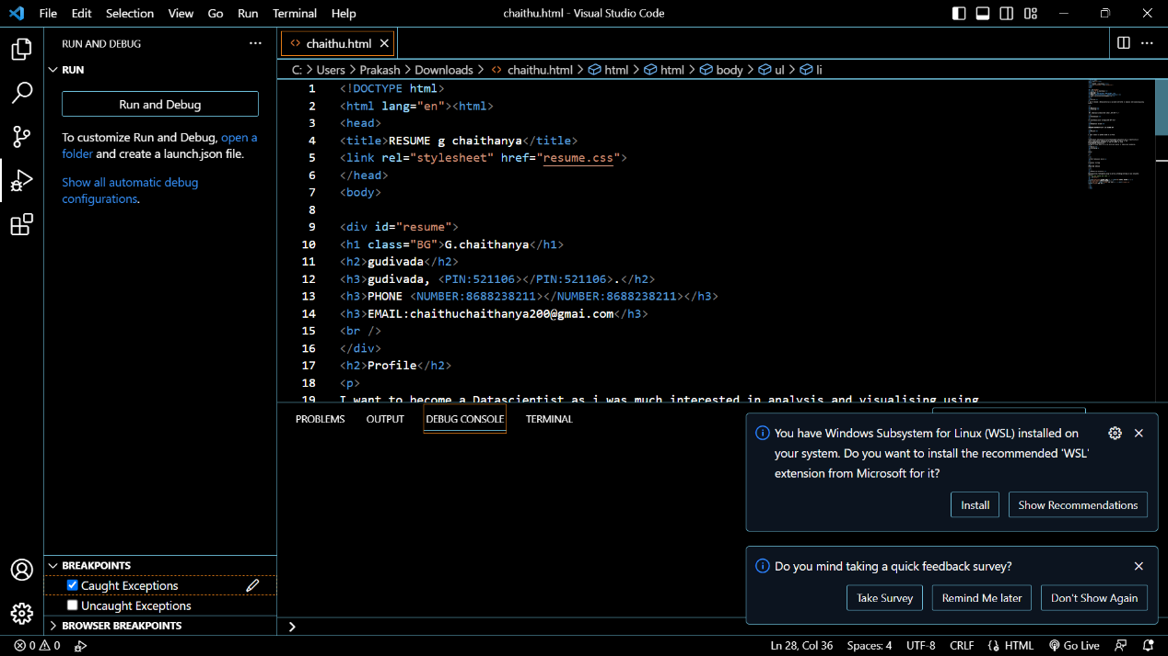

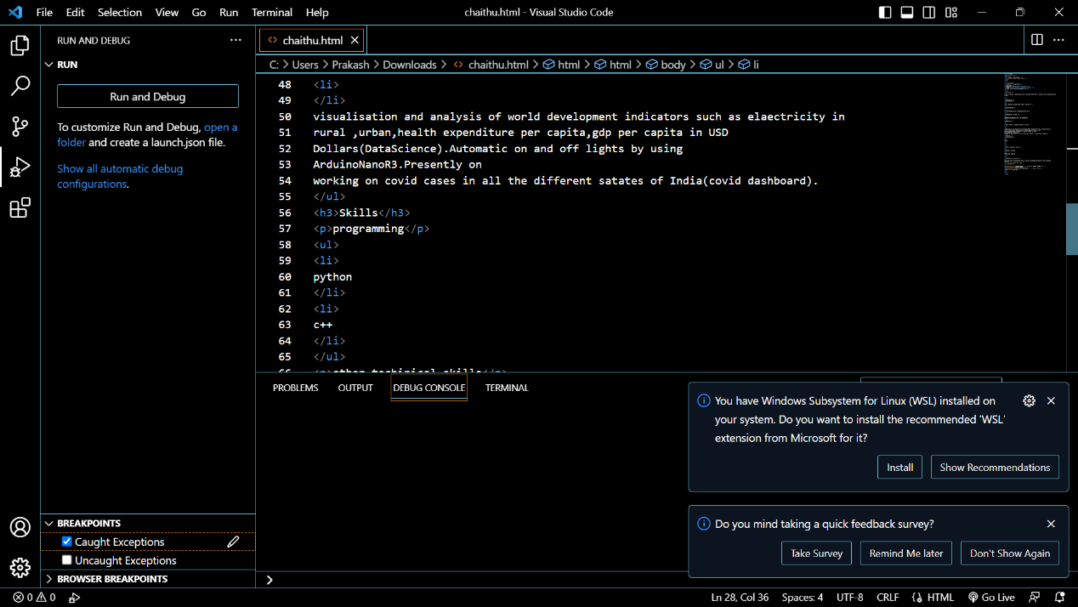

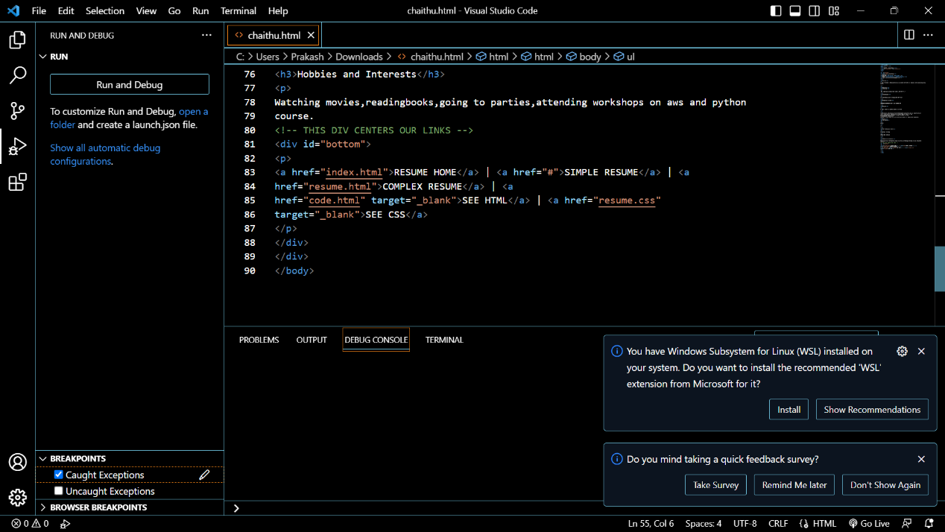

OUTPUT:

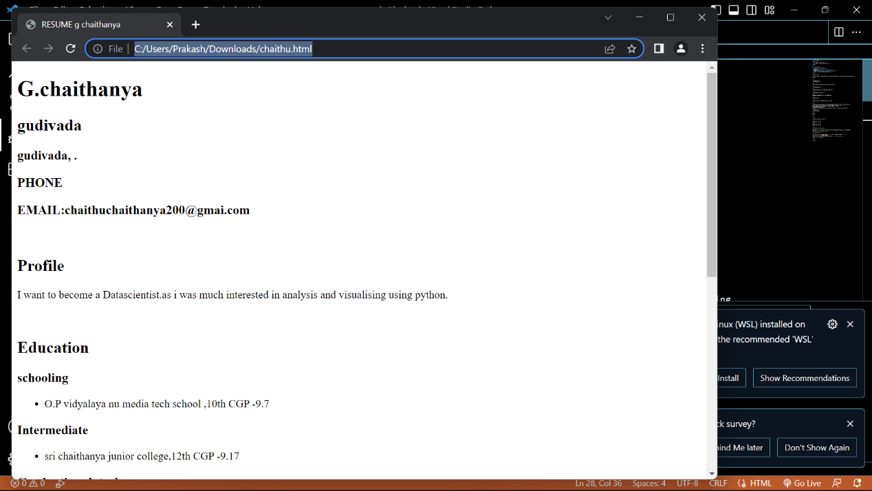

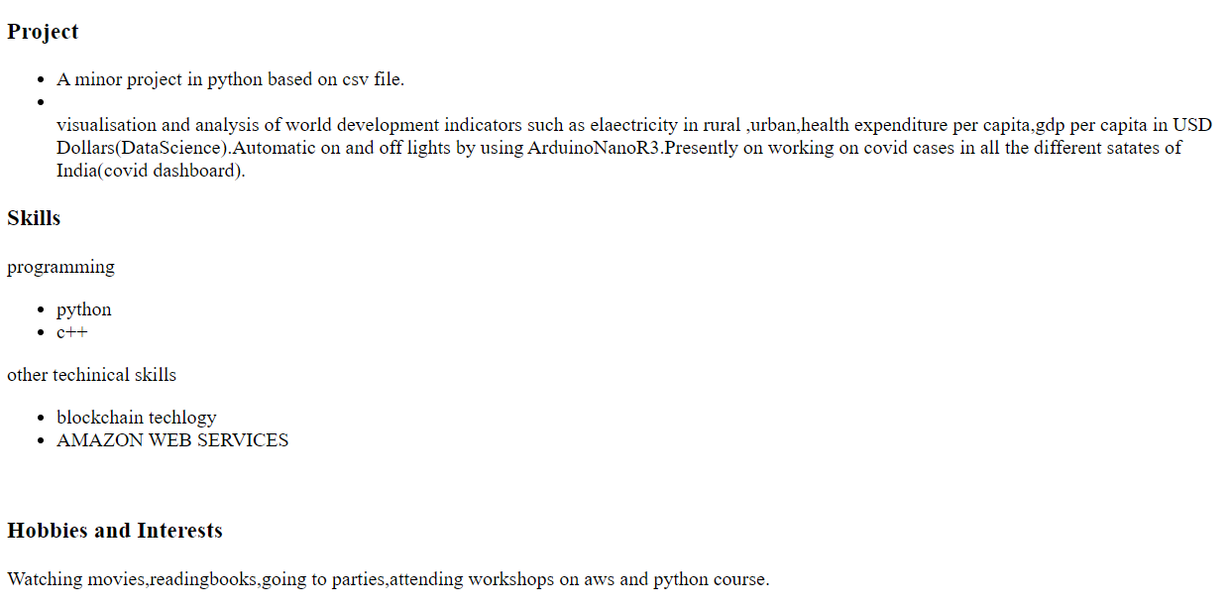

**EXPERIMENT 2**

1. ML code to create a Home page having three links: About Us, Our Services and Contact Us. Create separate web pages for the three links.

CODE:

ABOUT US:

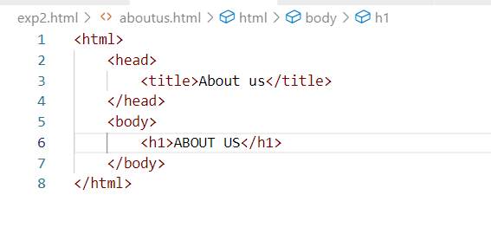

OUTPUT:

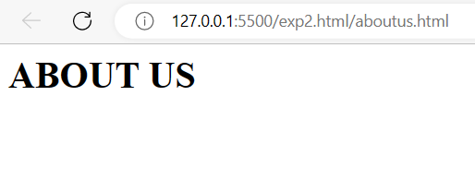

CONTACT US:

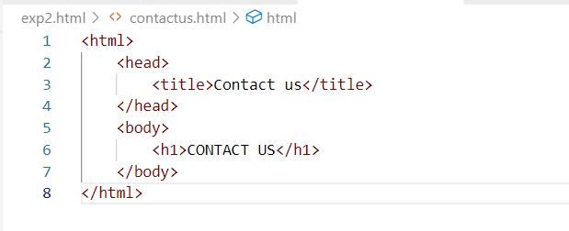

OUTPUT:

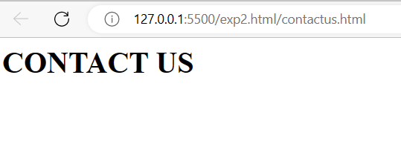

OURSERVICES:

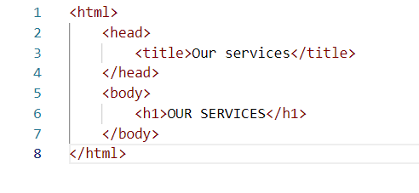

OUTPUT:

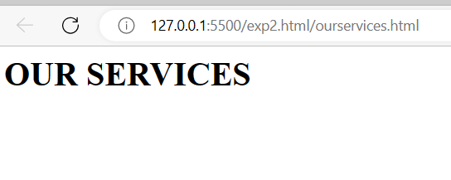

FINAL:

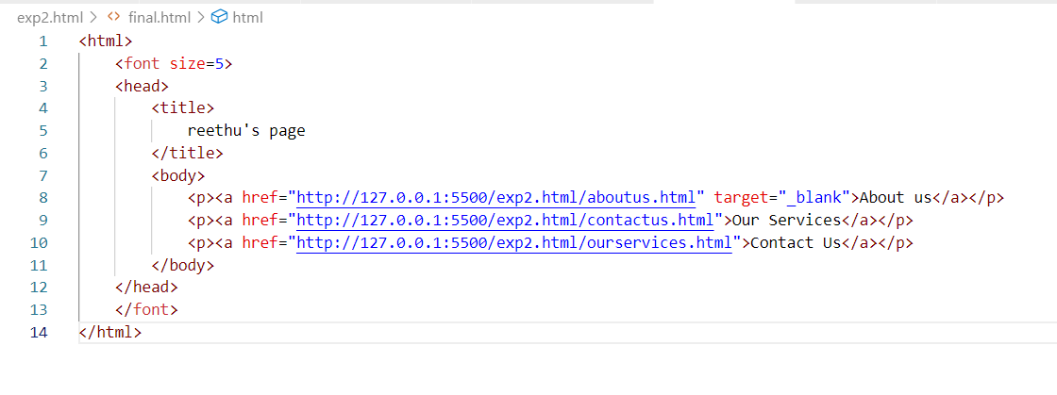

OUTPUT:

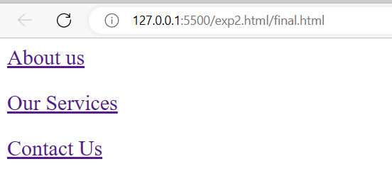

**EXPERIMENT 3**

1. Write an HTML code to create a Registration Form. On submitting the form, the user should be asked to login with this new credentials.

CODE:

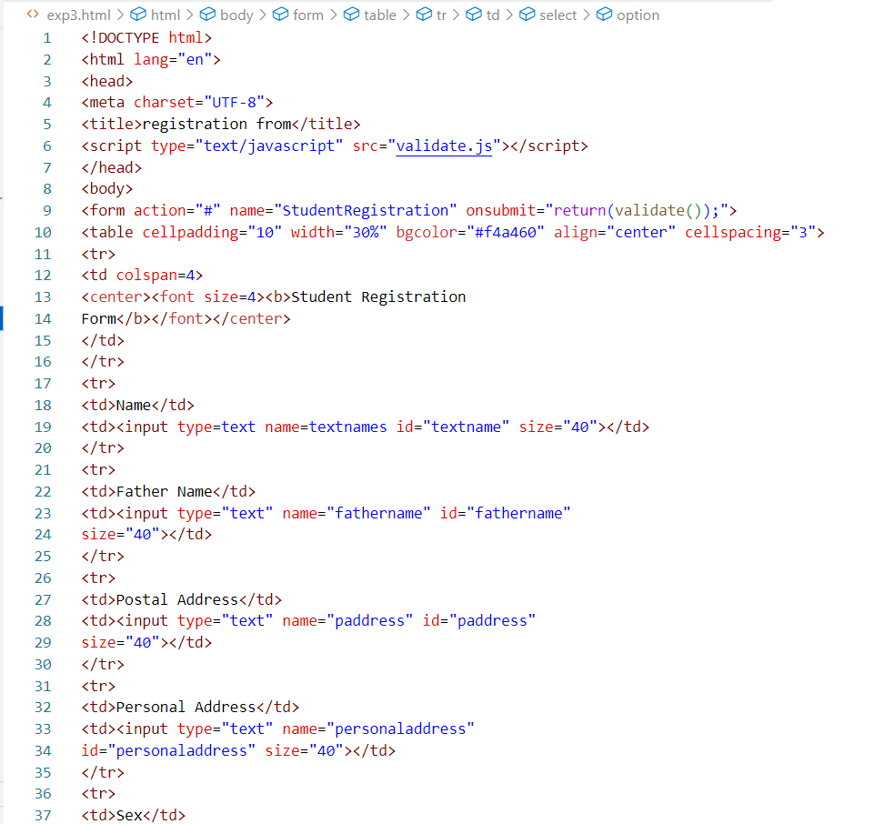

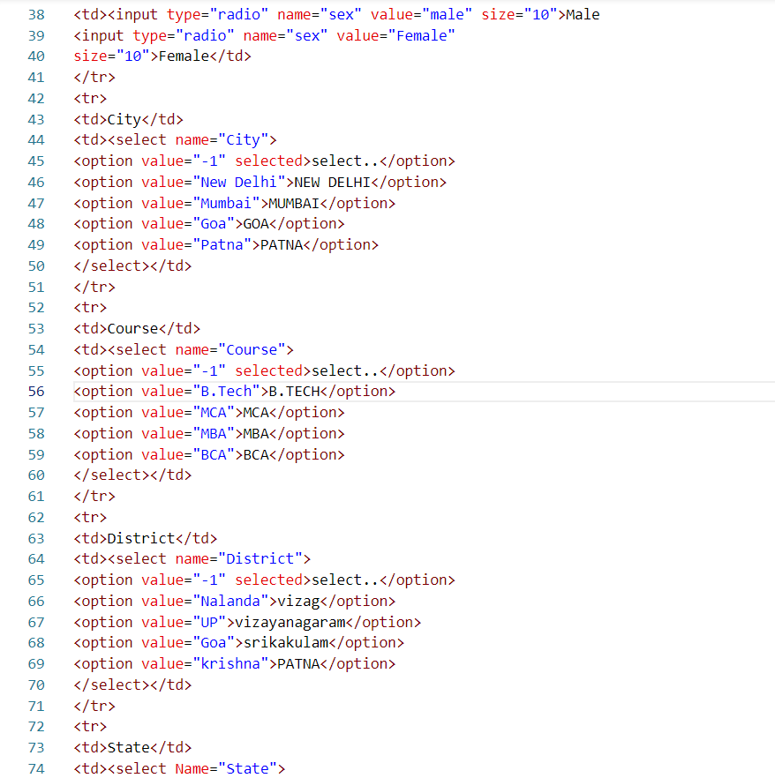

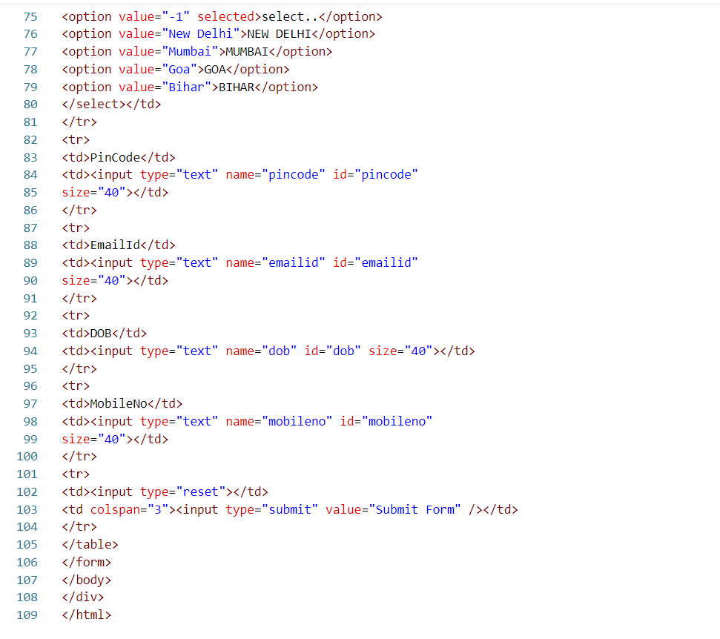

OUTPUT:

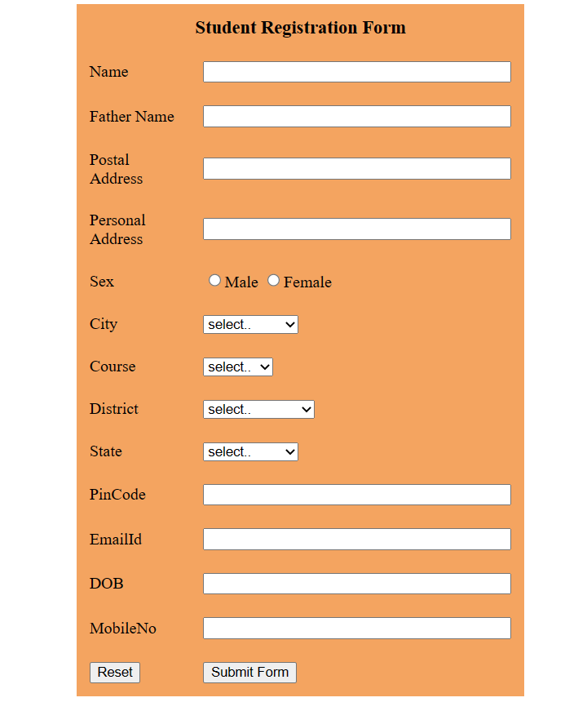

**EXPERIMENT 4**

1. Write an HTML code to create your Institute website, Department Website and Tutorial website for specific subject.

CODE:

4.0

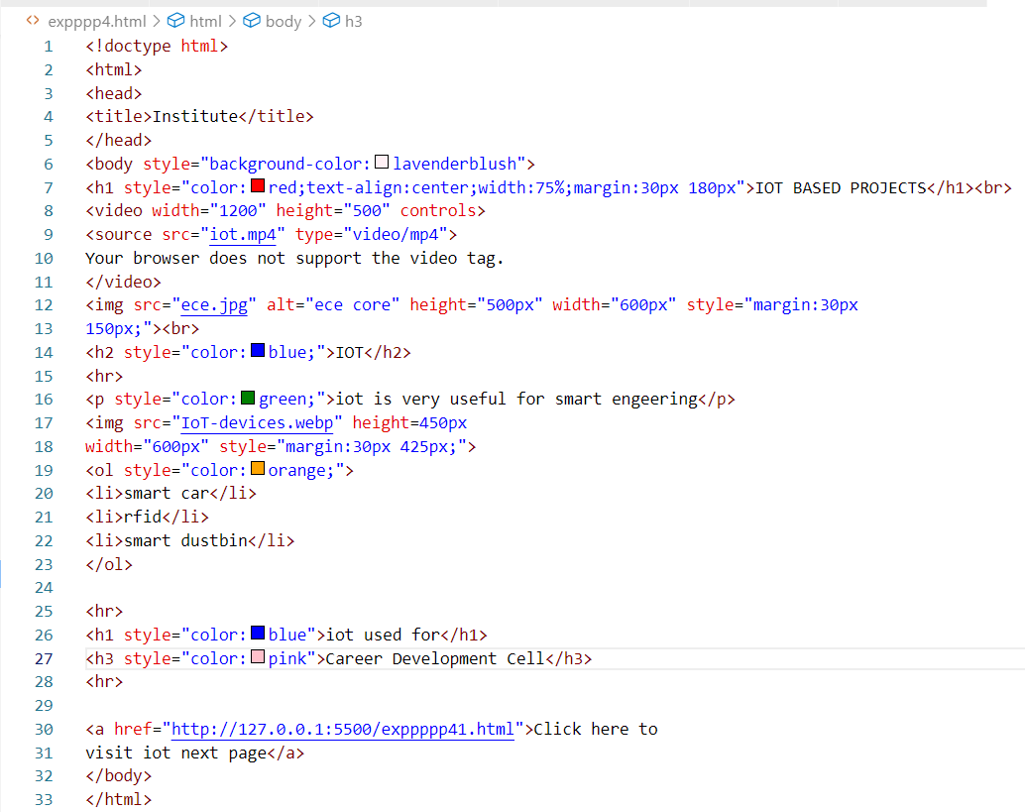

OUTPUT:

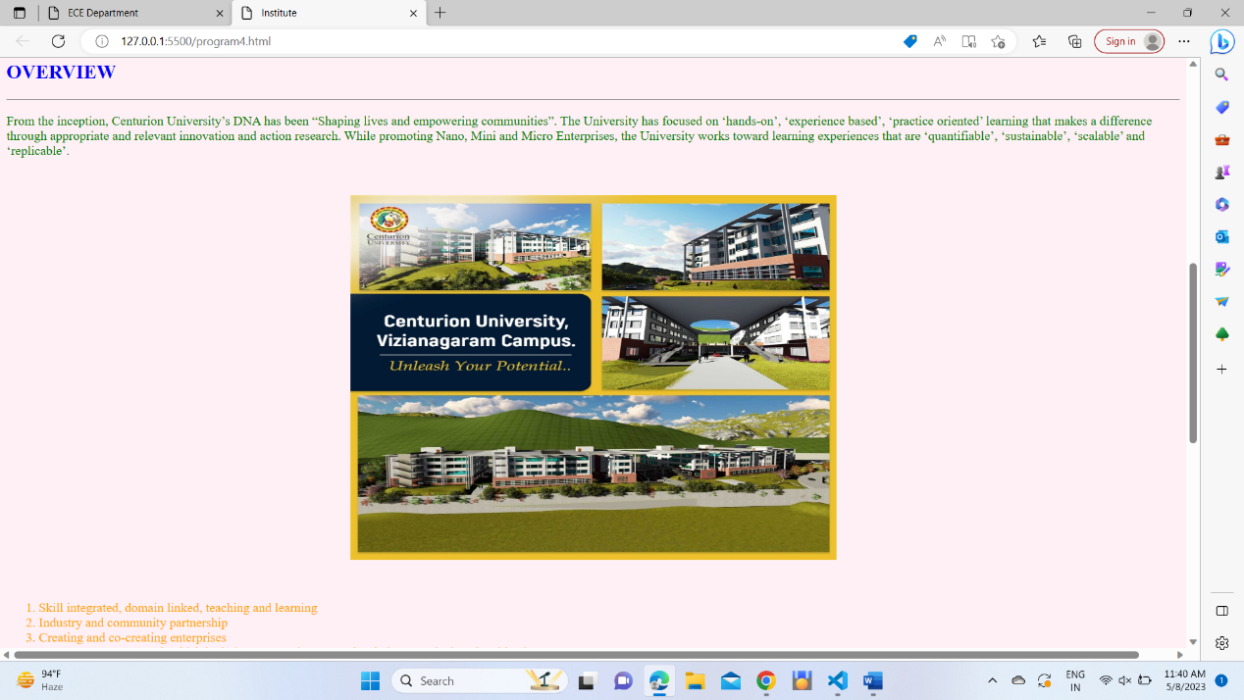

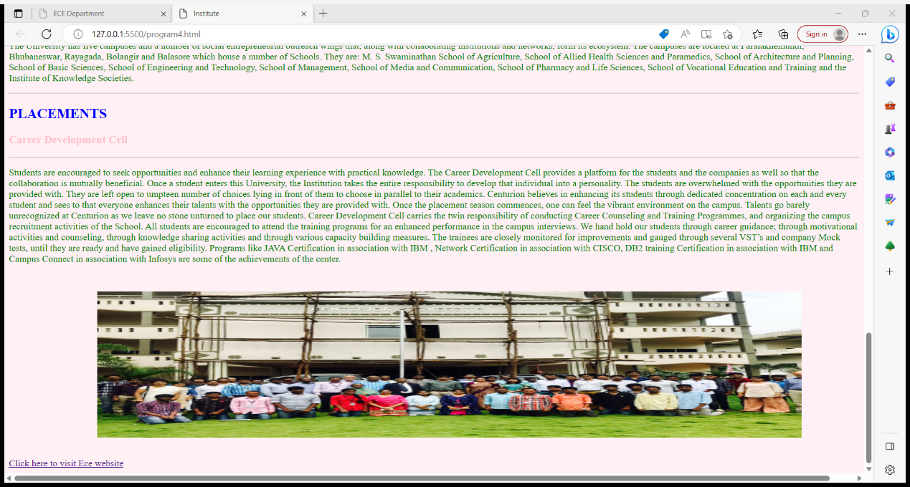

CODE 4.1:

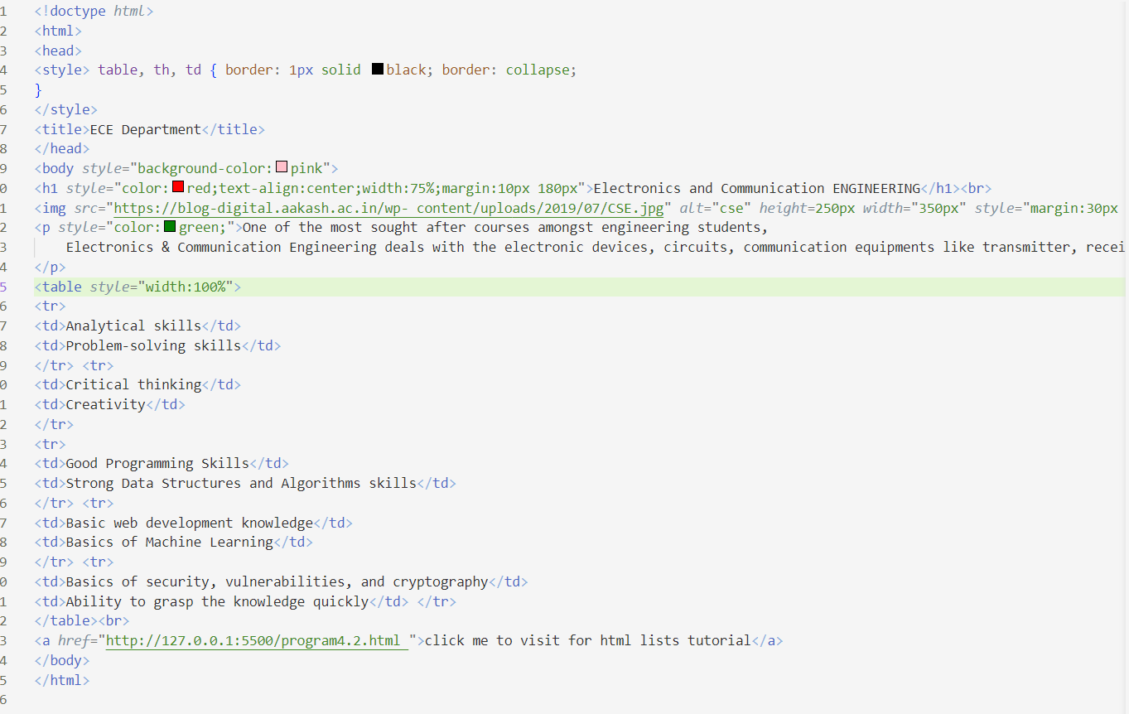

OUTPUT:

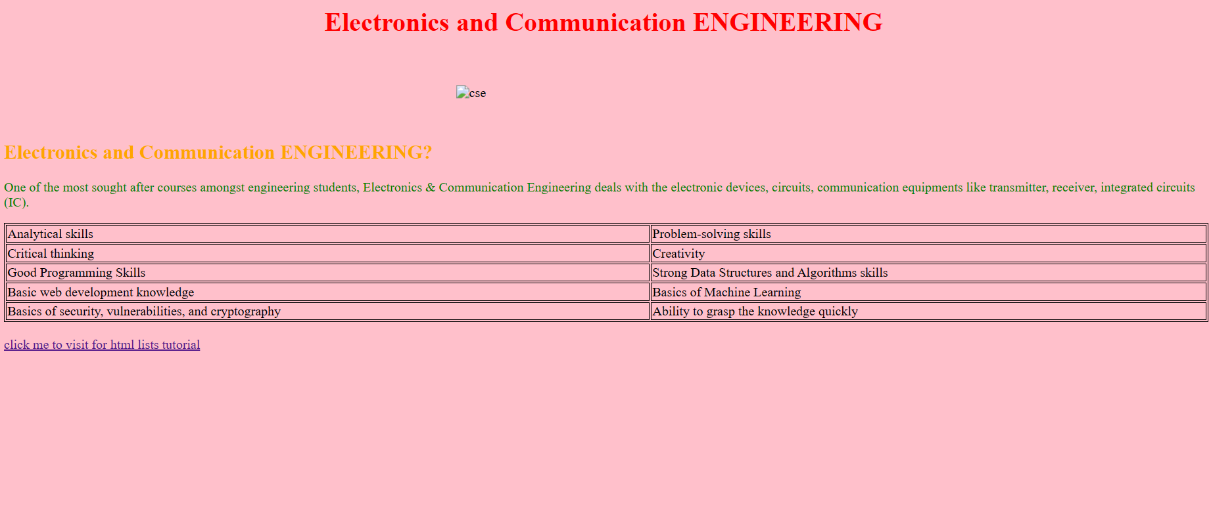

CODE 4.2

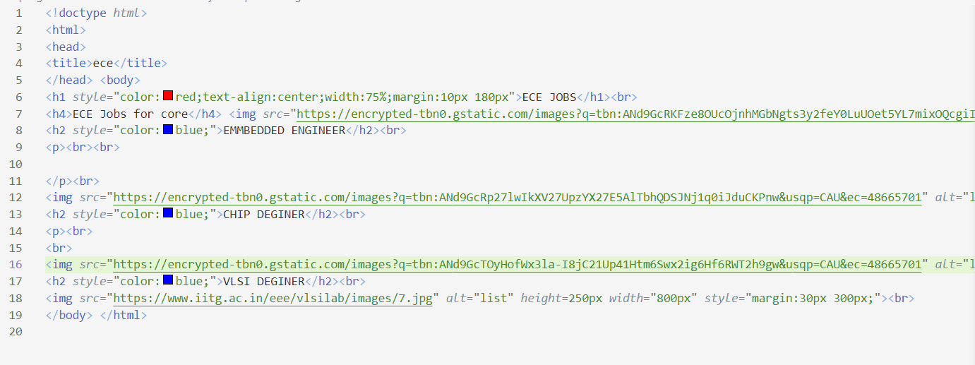

OUTPUT:



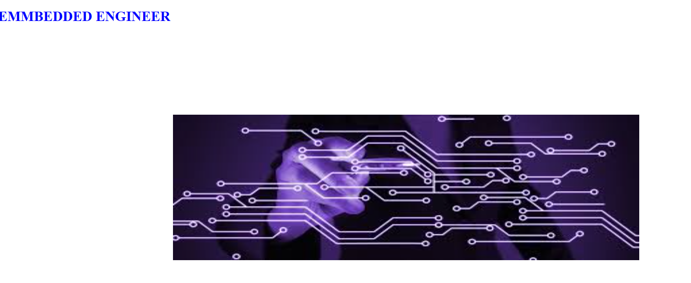

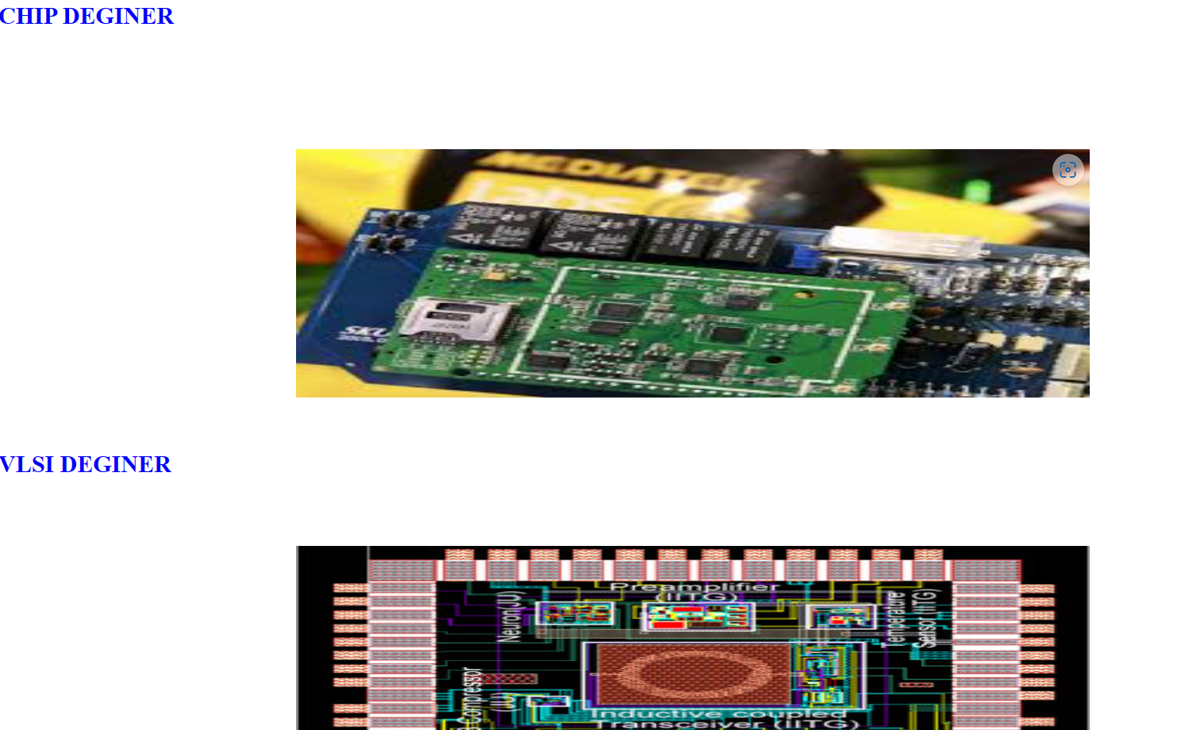

**EXPERIMENT 5**

1. Write an HTML code to create a frameset having header, navigation and contentsections

CODE:

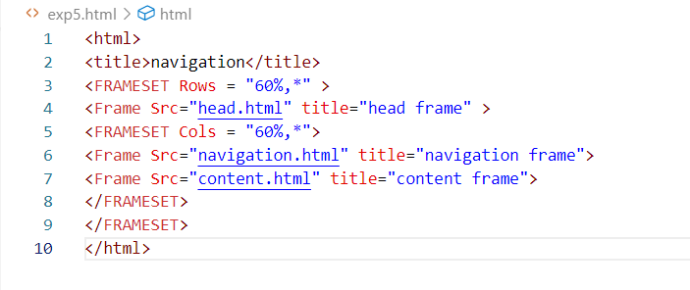

OUTPUT:

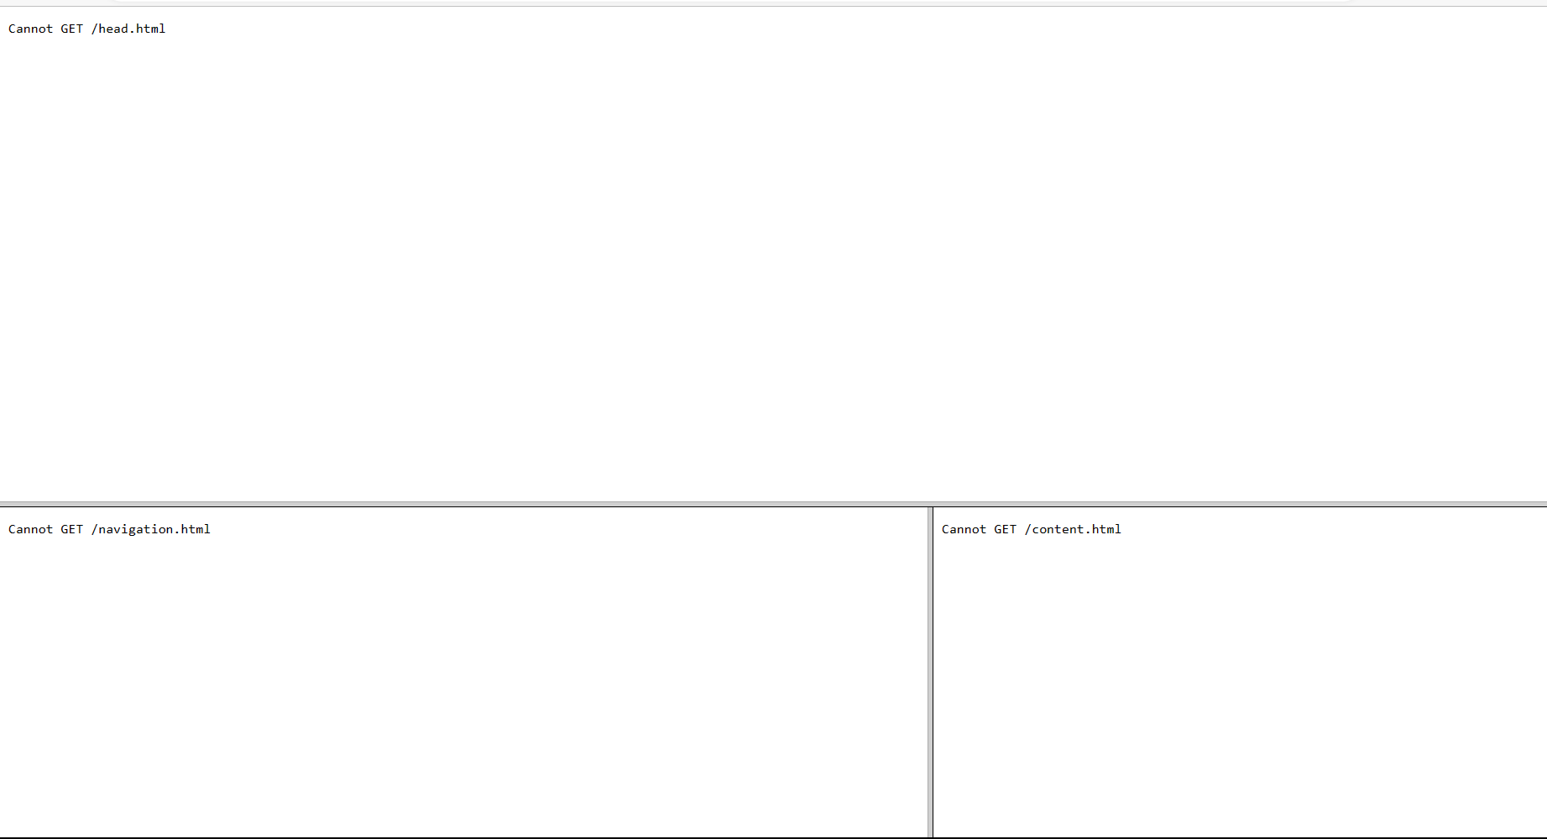

**EXPERIMENT 6**

1. Write an HTML code to demonstrate the usage of inline CSS.

CODE:

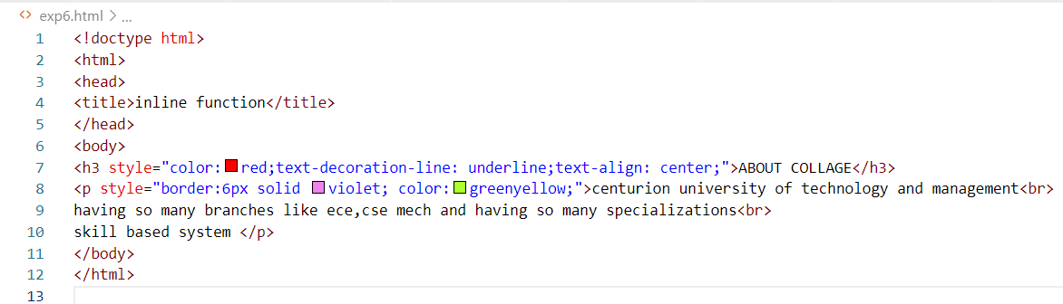

OUTPUT:

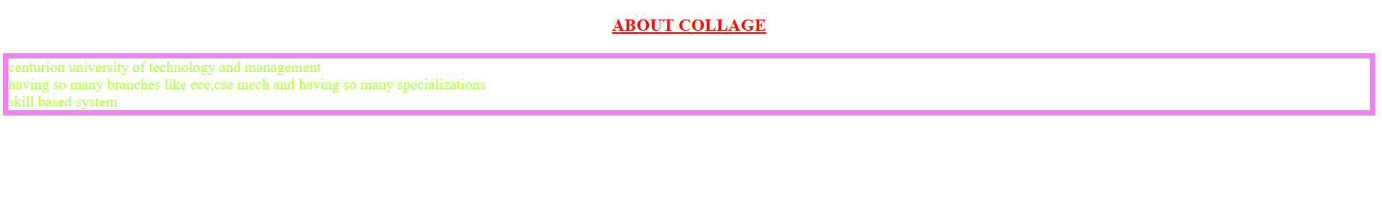

**EXPERIMENT 7**

1. Write an HTML code to demonstrate the usage of internal CSS.

CODE:

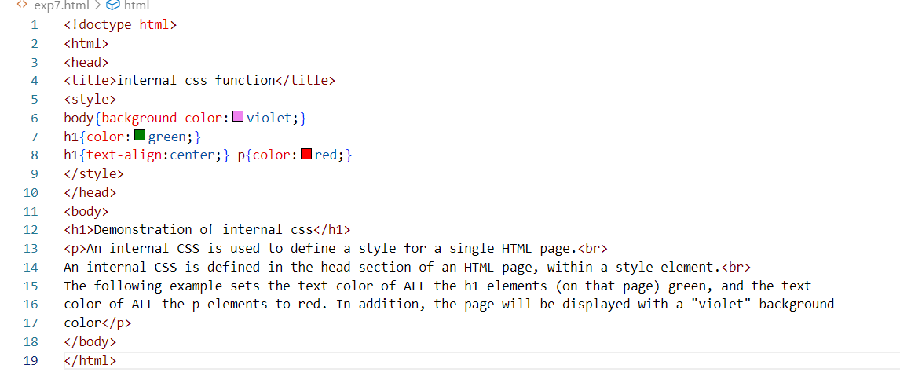

OUTPUT:

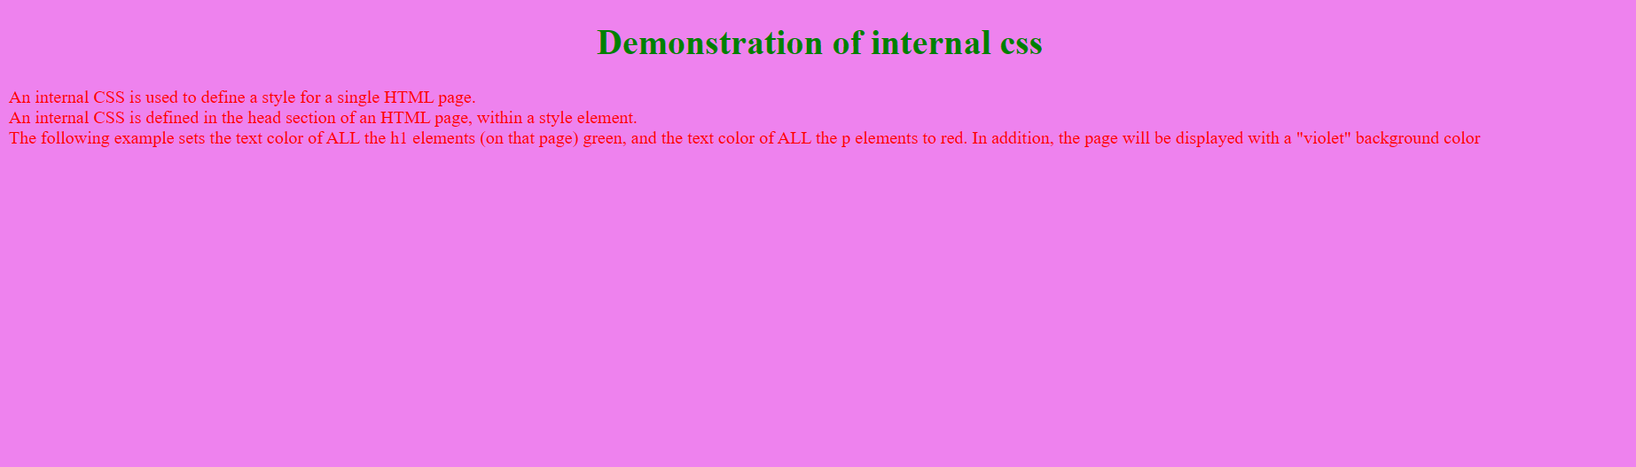

**EXPERIMENT 8**

1. Write an HTML code to demonstrate the usage of external CSS.

CODE:

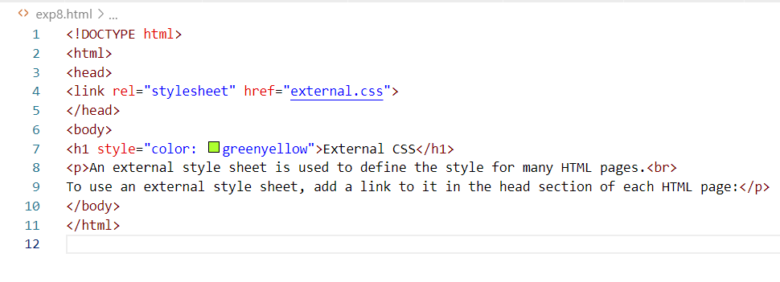

OUTPUT:

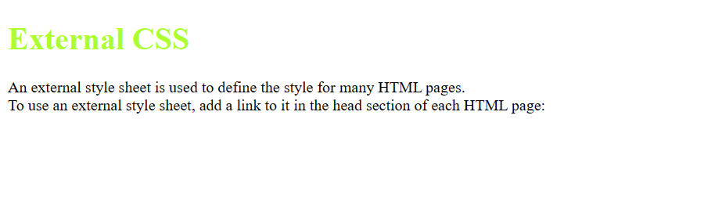

**EXPERIMENT 9**

**9.**Design your own website using HTML CSS.

CODE:

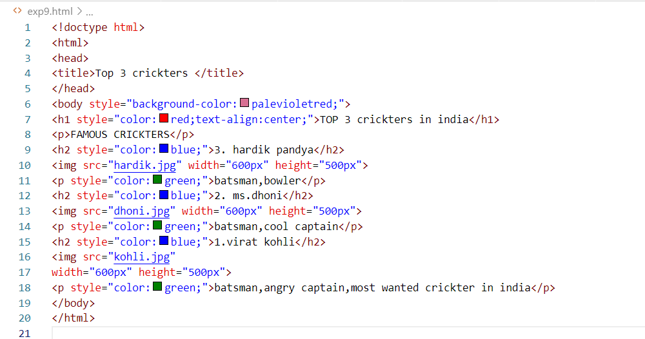

OUTPUT:

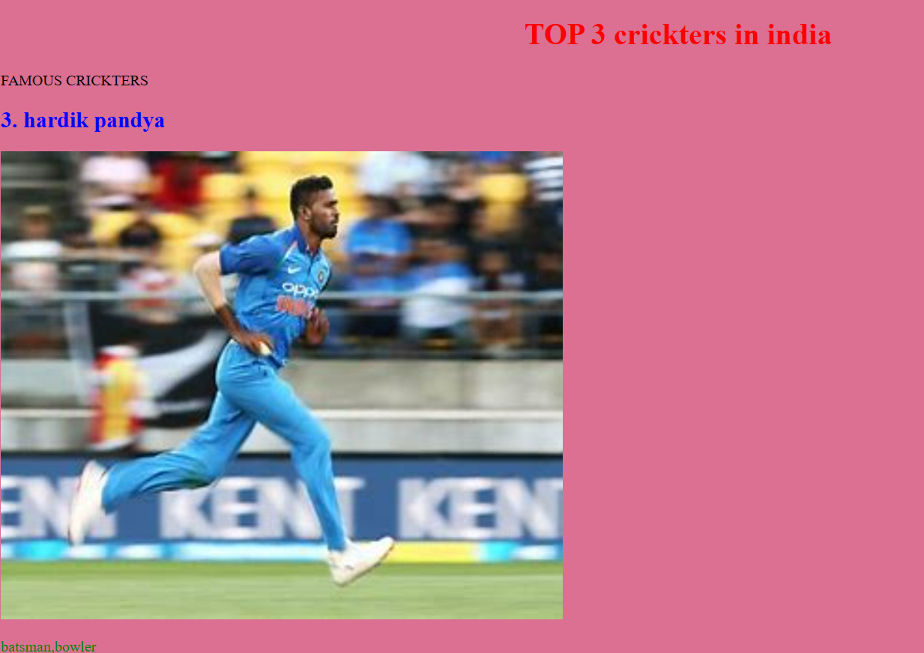

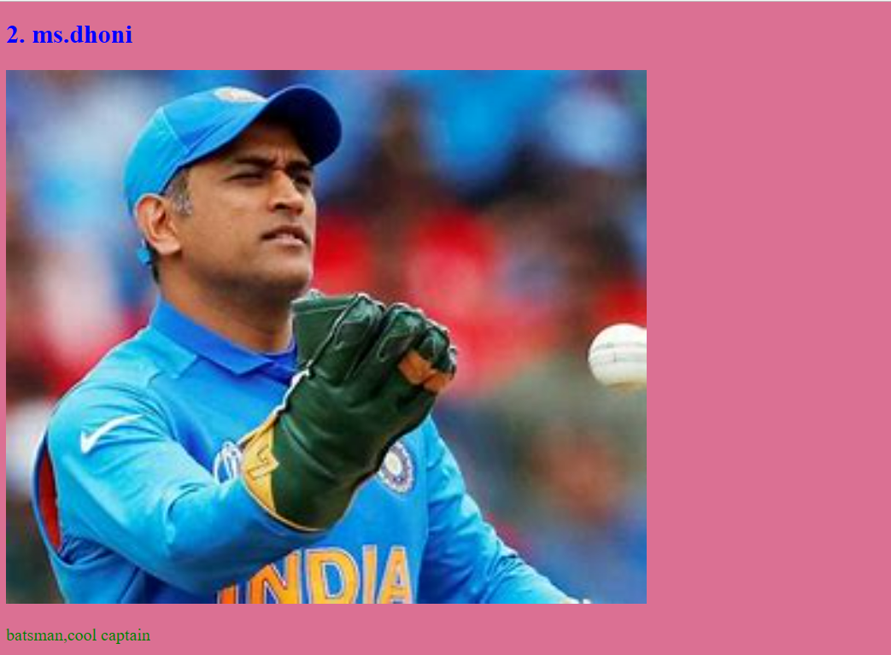

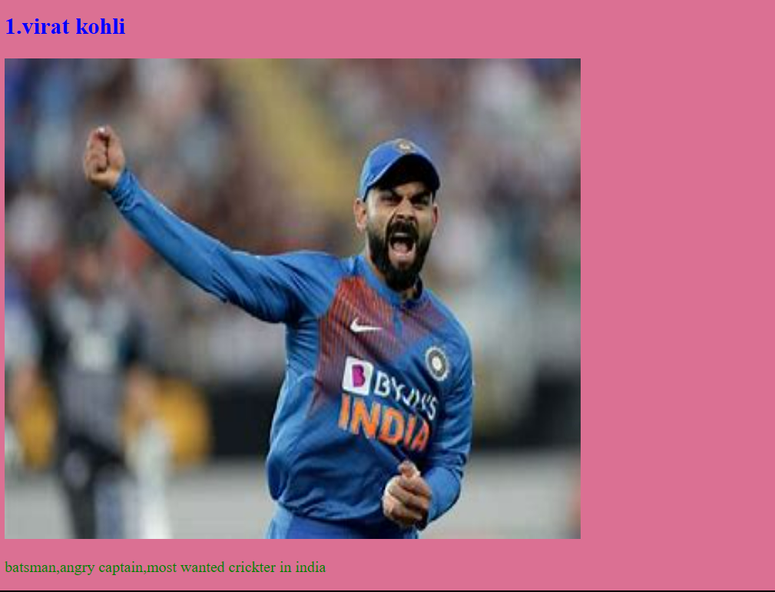

**EXPERIMENT 10**

**10.**.Design form using HTML and apply CCS.

CODE:

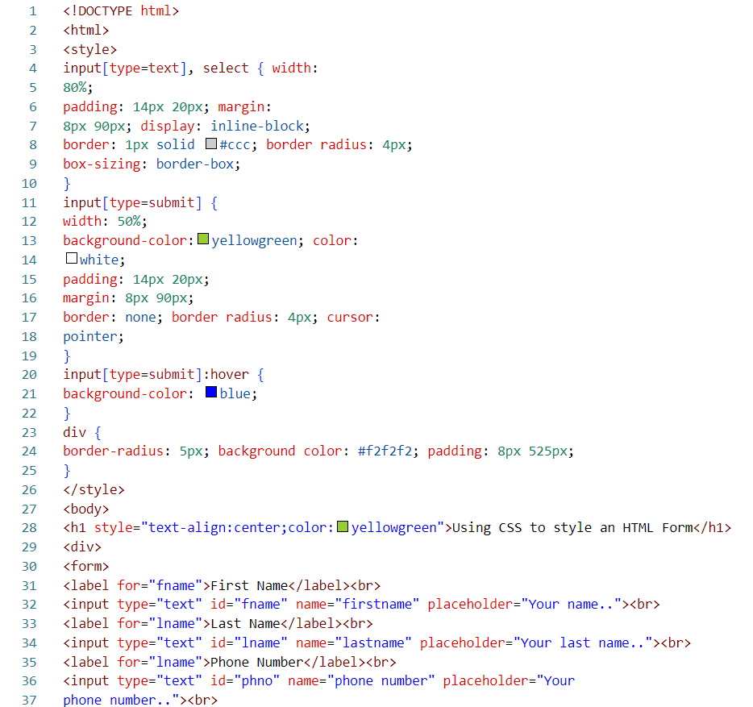

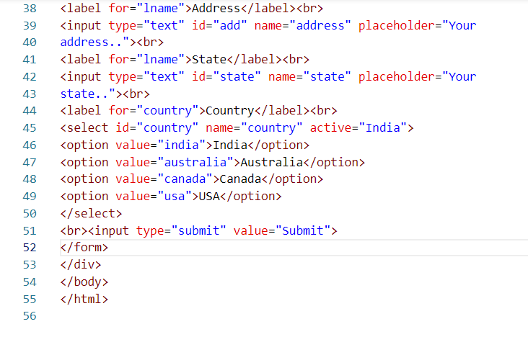

OUTPUT:

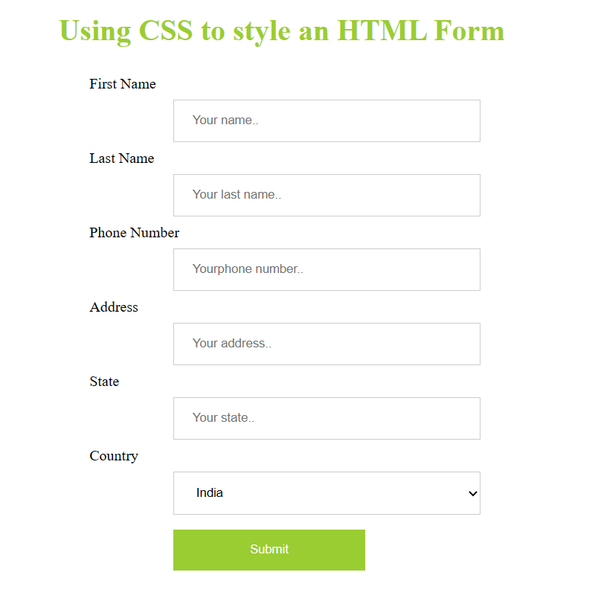

**EXPERIMENT 11**

**11.**Write a Java script to prompt for users name and display it on the screen.

CODE:

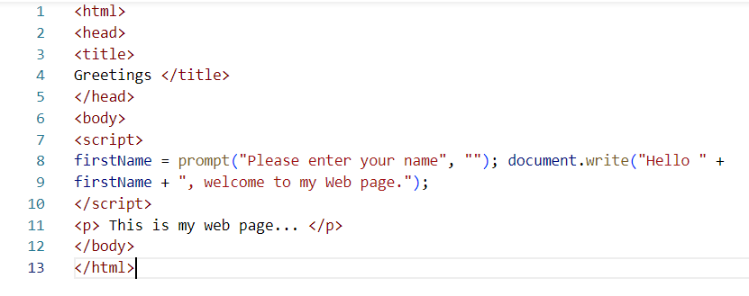

OUTPUT:

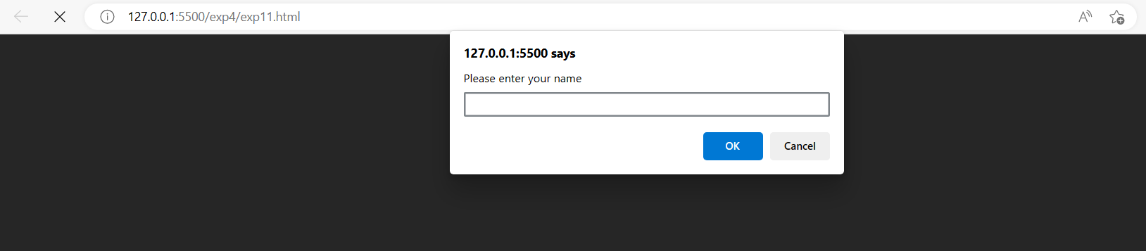

**EXPERIMENT 12**

**12.**Design HTML form for keeping student record and validate it using Java script.

CODE:

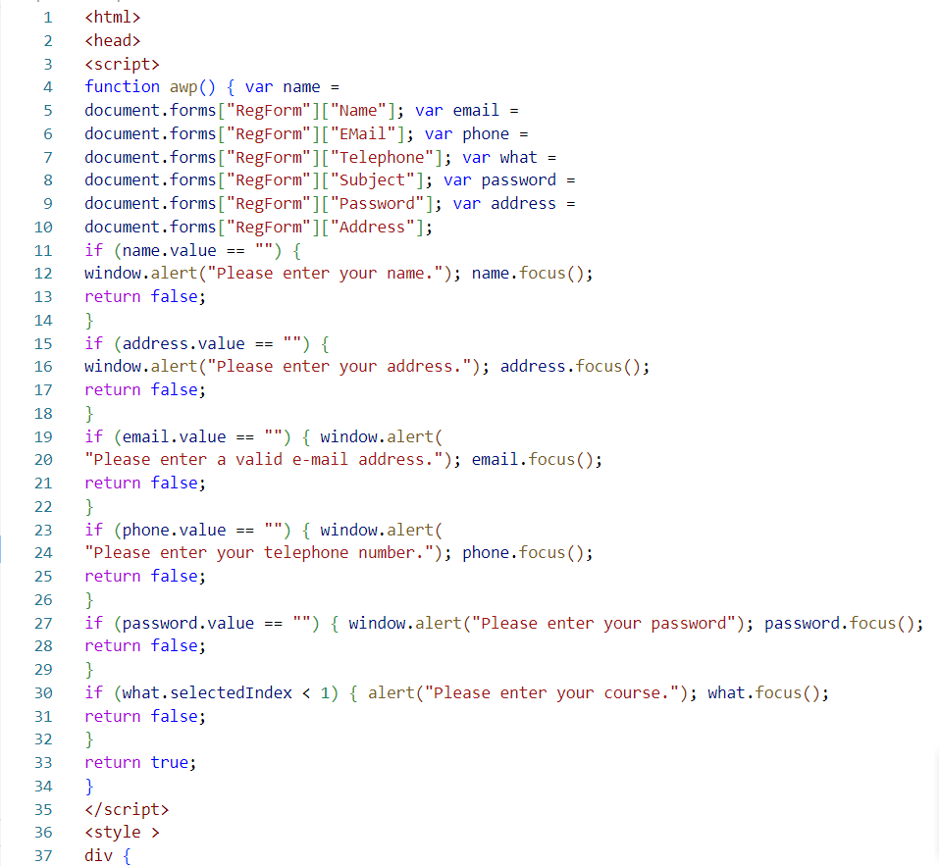

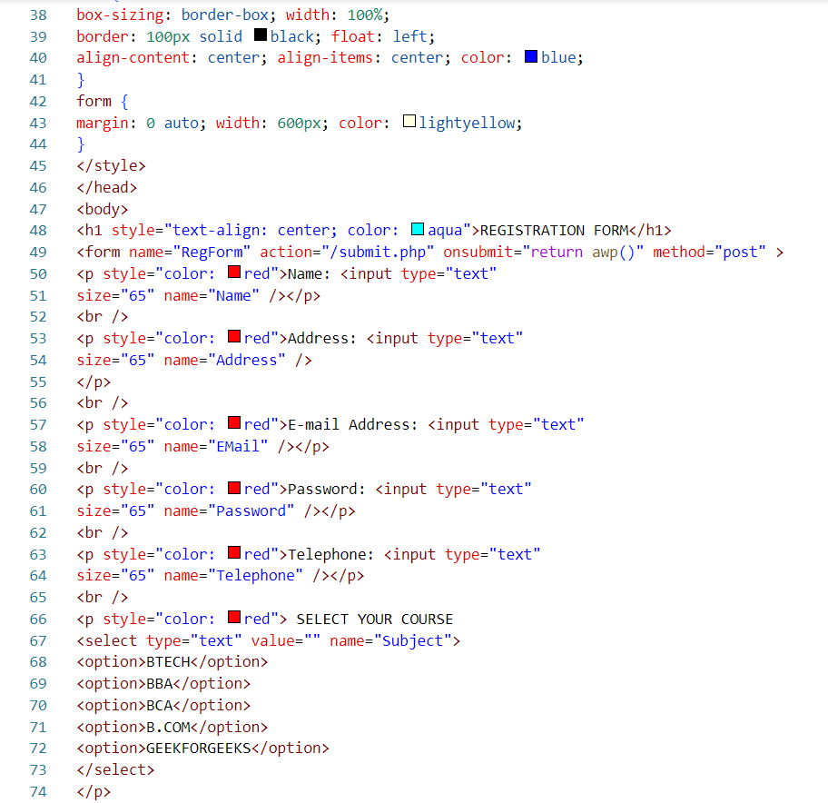

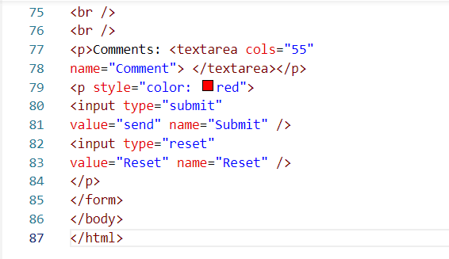

OUTPUT:

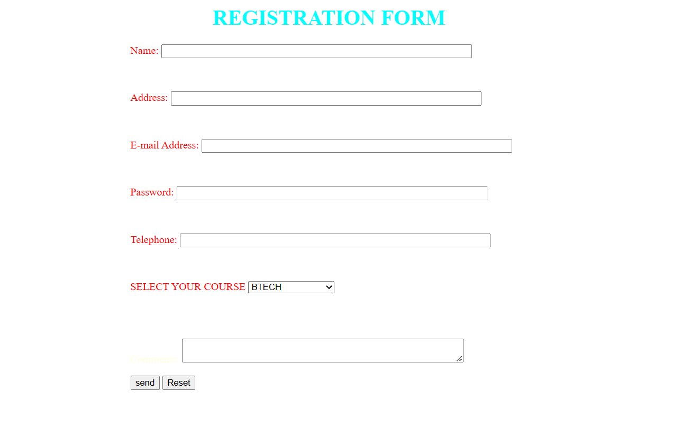

**EXPERIMENT 13**

**13.**Write programs using Java script for Web Page to display browsers information.

CODE:

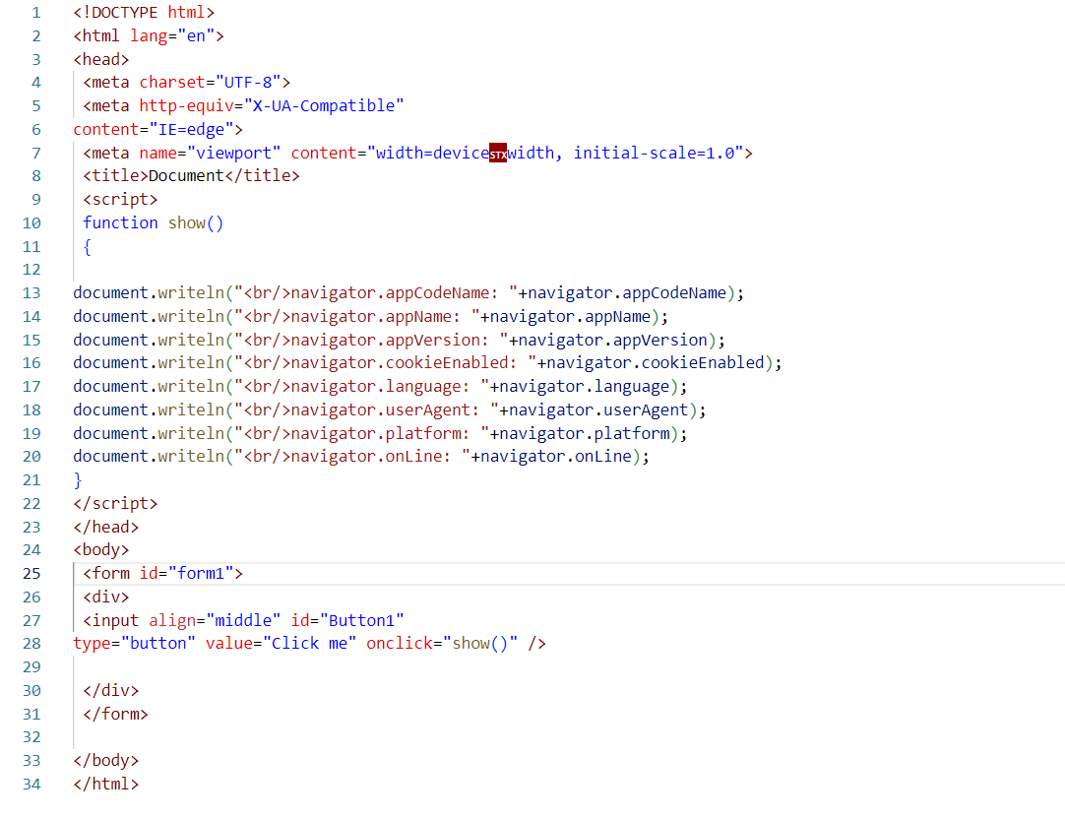

OUTPUT:

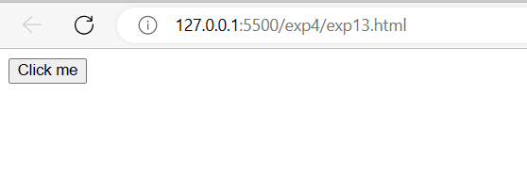

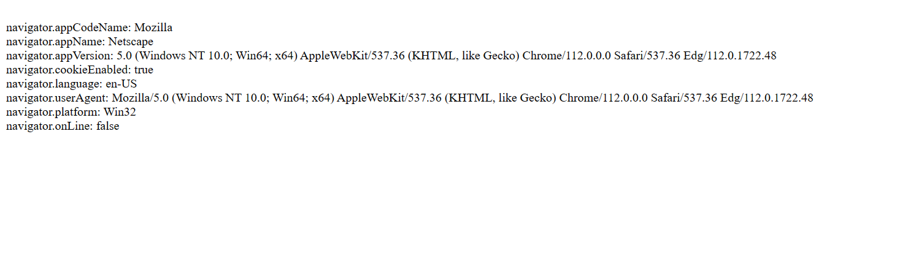

**EXPERIMENT 14**

**14.** Validate form page using JavaScript

CODE:

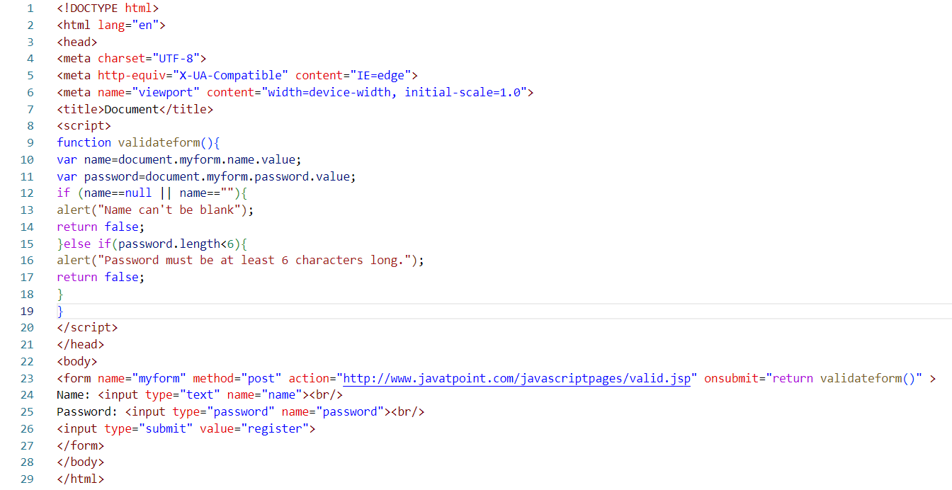

OUTPUT:

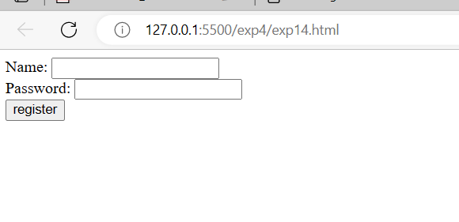

**EXPERIMENT 15**

**15.**Use JQuery hide() effect in page**.**

CODE:

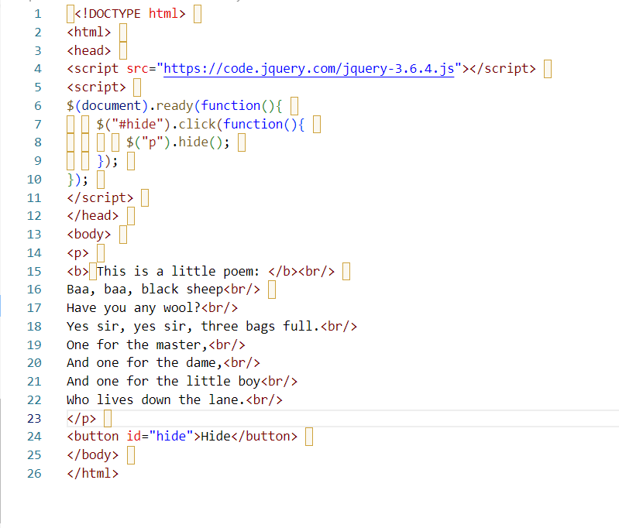

OUTPUT:

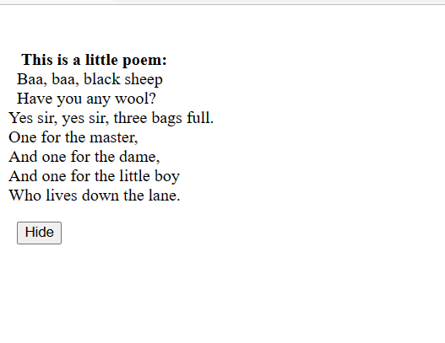

**EXPERIMENT 16**

**16.**Write a jQuery Code to Find the data passed with the on() method for each element.

CODE:

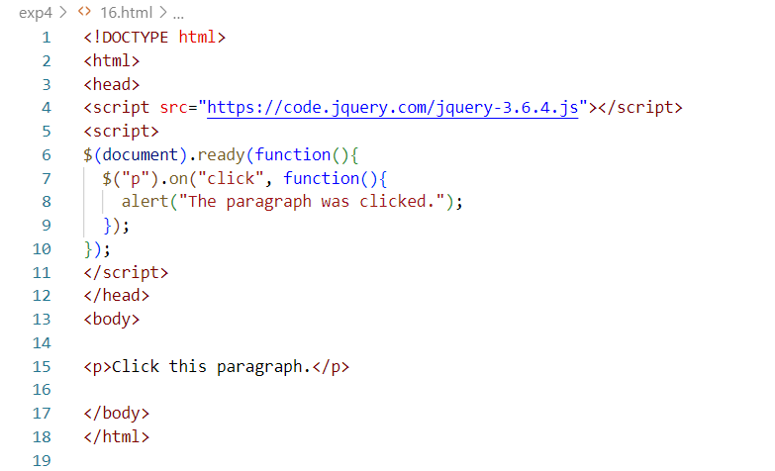

OUTPUT:

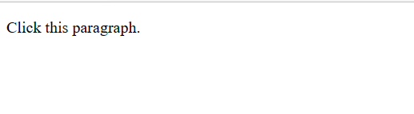

**EXPERIMENT 17**

**17.**Find the position of the mouse pointer relative to the left and top edges of the document.

CODE:

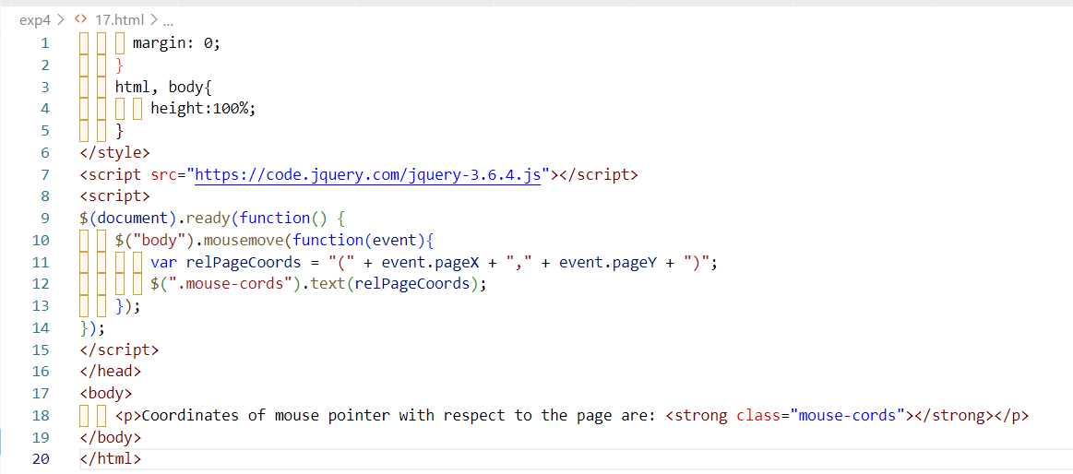

OUTPUT:

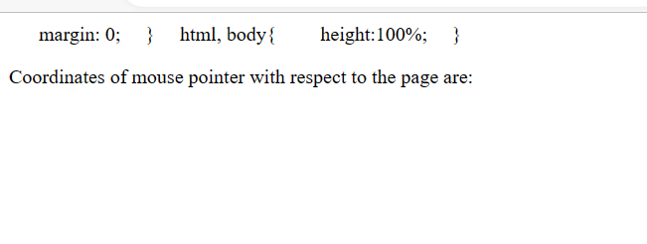

**EXPERIMENT 18**

**18.**Count the number of milliseconds between the two click events on a paragraph.

CODE:

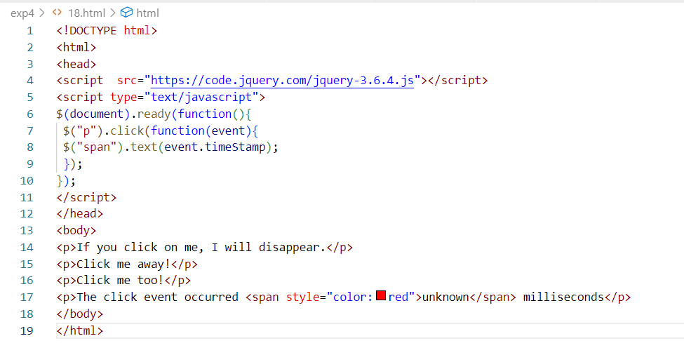

OUTPUT:

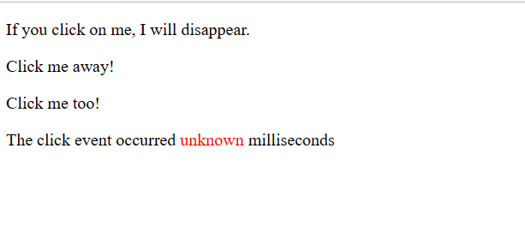

**EXPERIMENT 19**

**19.**Find all the text nodes inside a paragraph and wrap them with an italic tag.

CODE:

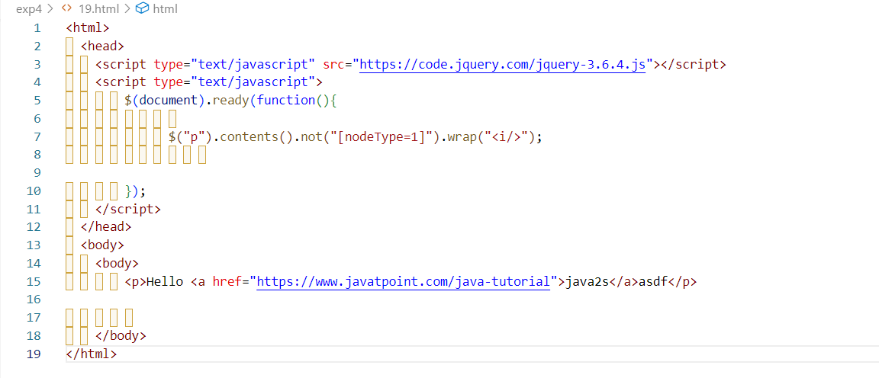

OUTPUT:

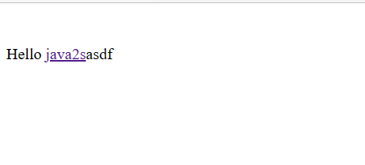

**EXPERIMENT-20**

20. Create a simple application using AJAX to show the table of numbers given by user at runtime

**CODE:**

**Code-20.html**

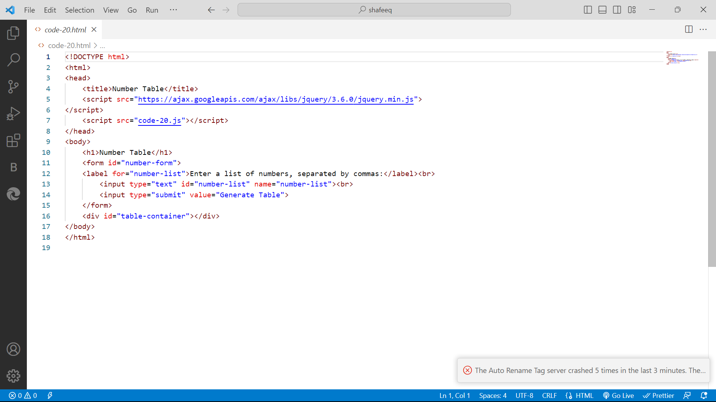

**Code-20.js**

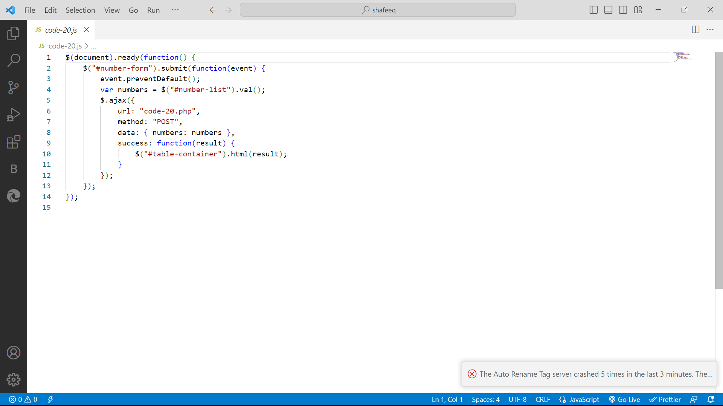

**Code-20.php**

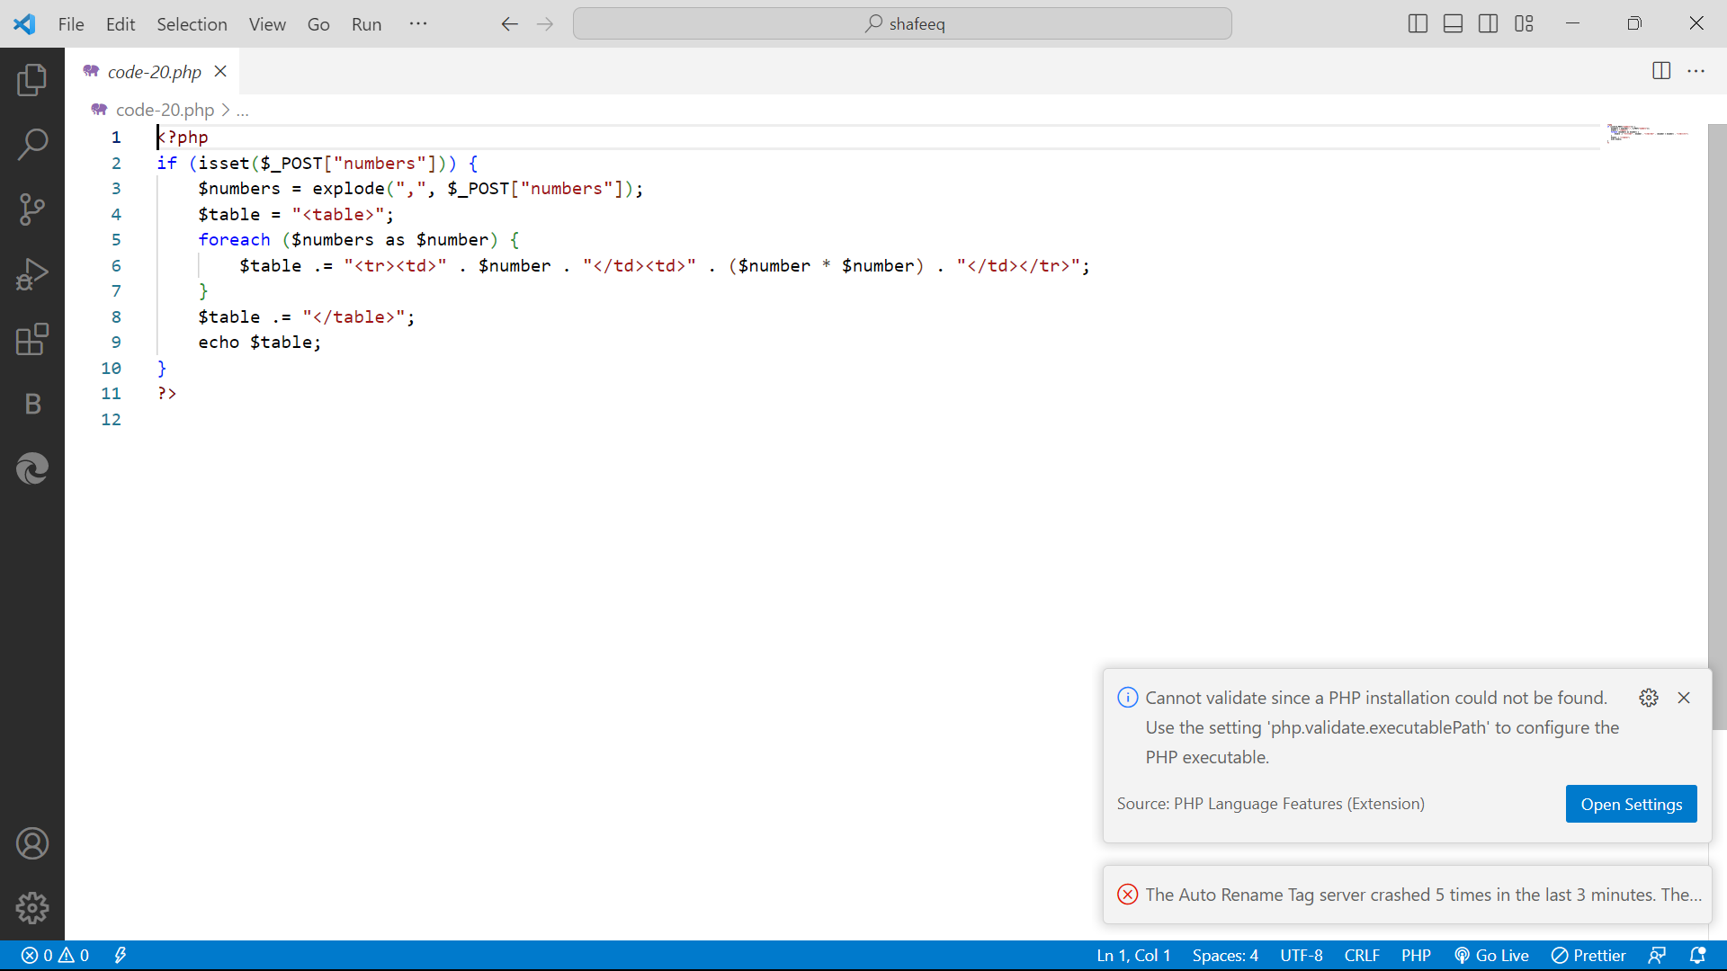

**OUTPUT:**

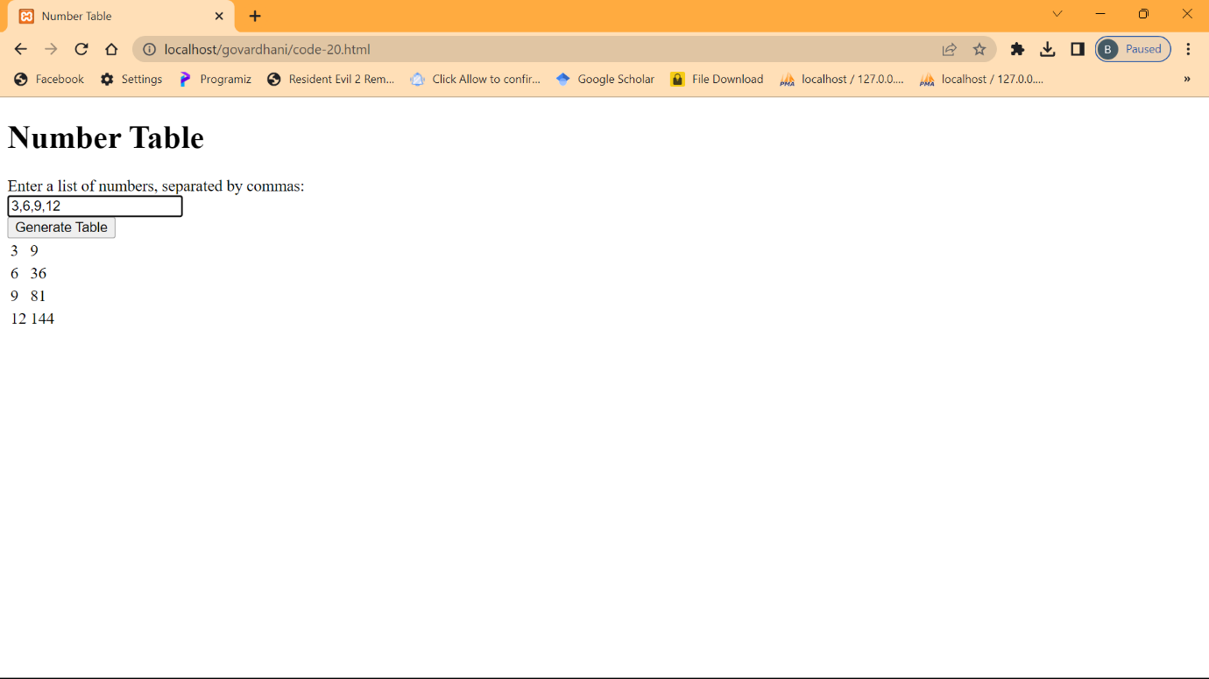

**EXPERIMENT-21**

21.Access web service using AJAX and handle using JSON

**CODE:**

**Code-21.js**

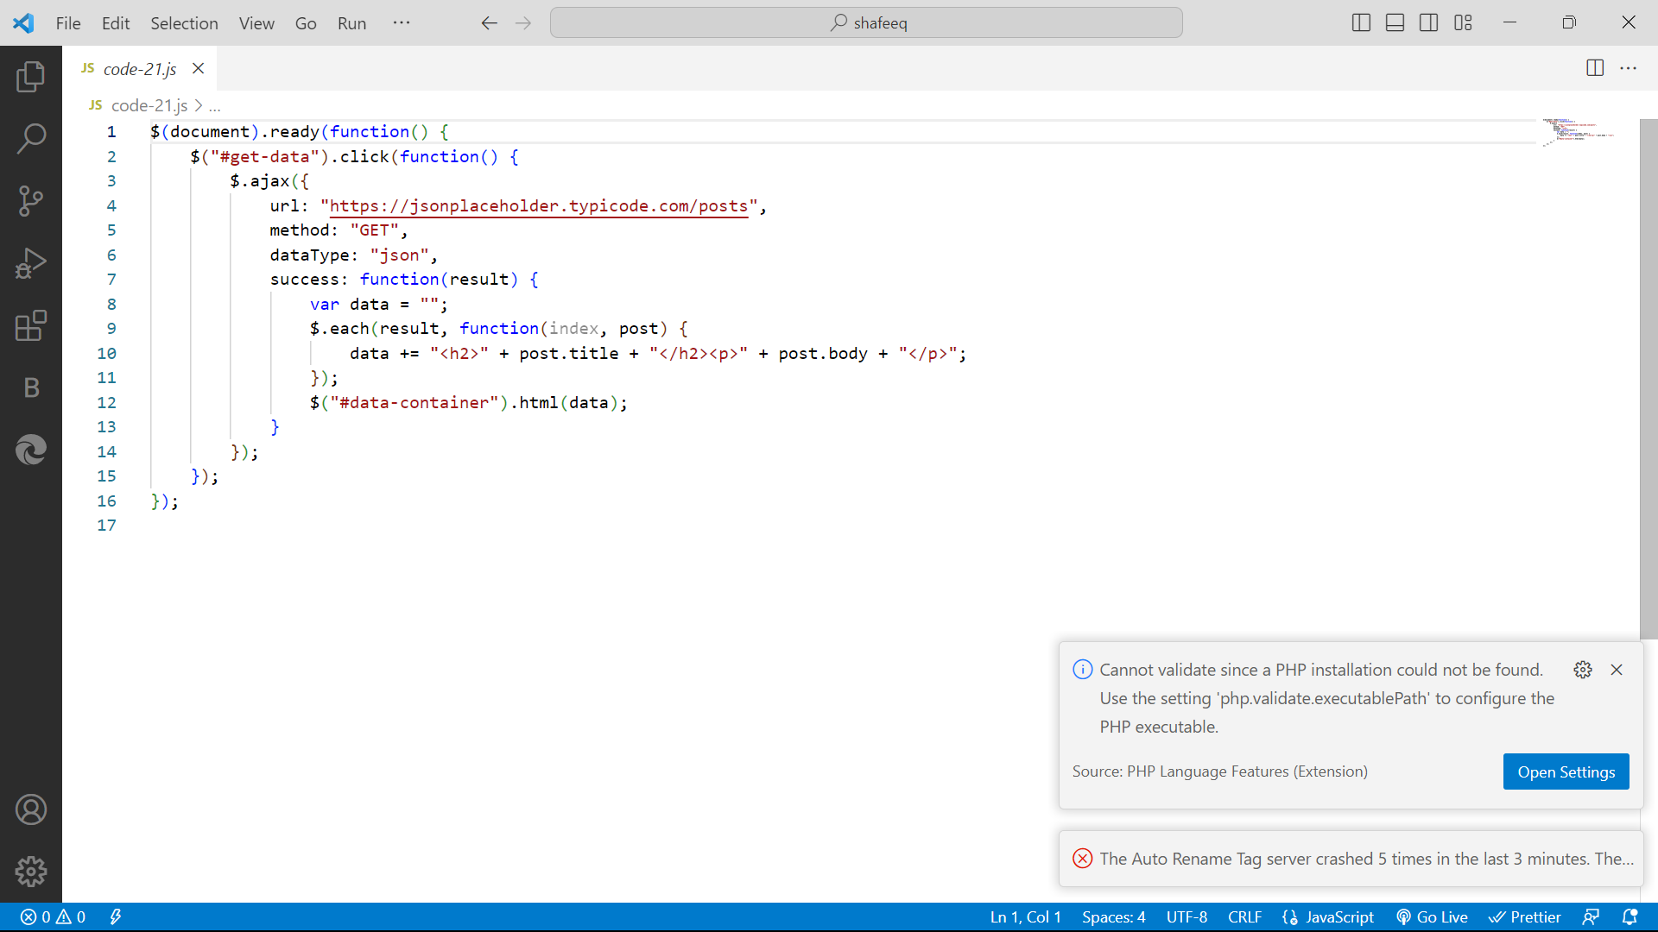

**Code-21.php**

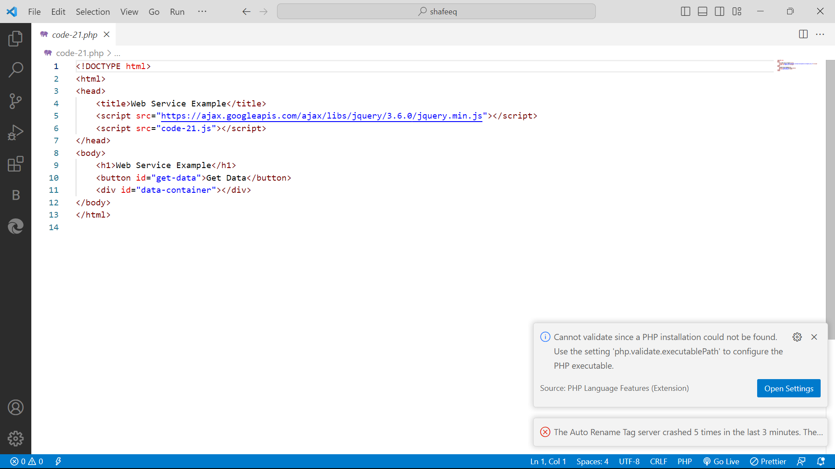

**OUTPUT:**

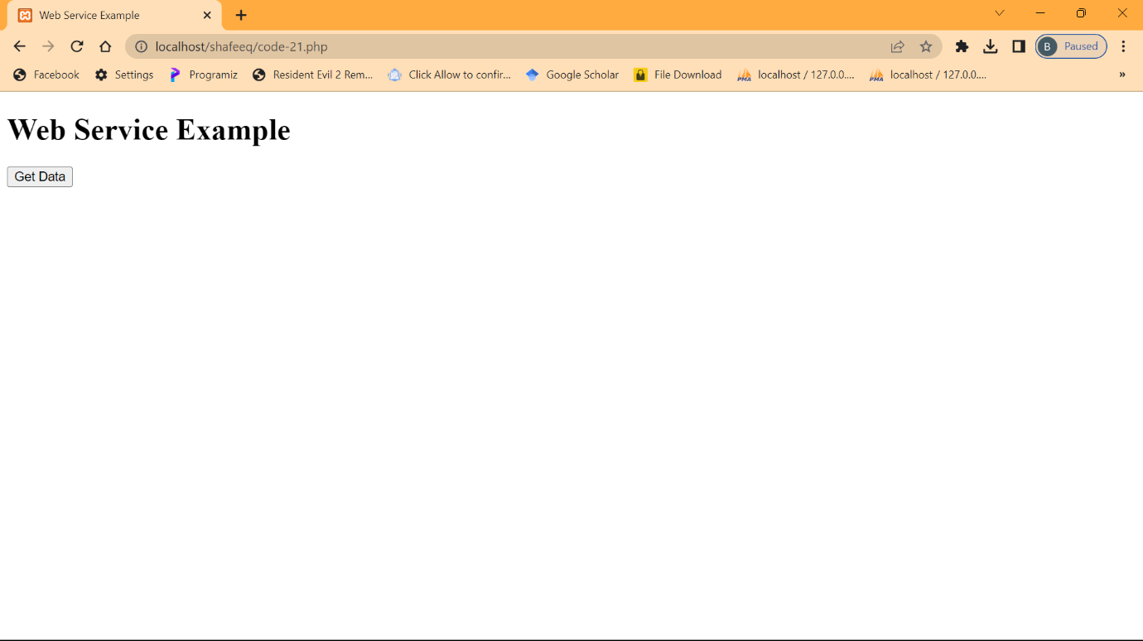

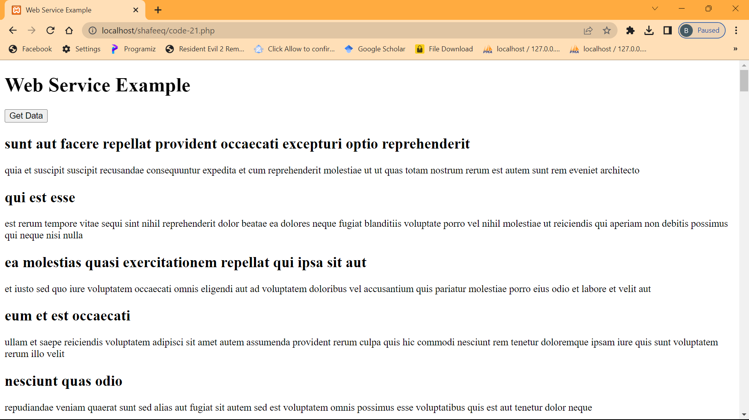

**EXPERIMENT-22**

22.create a responsive website using bootstrap

**CODE:**

**Code-22.html**

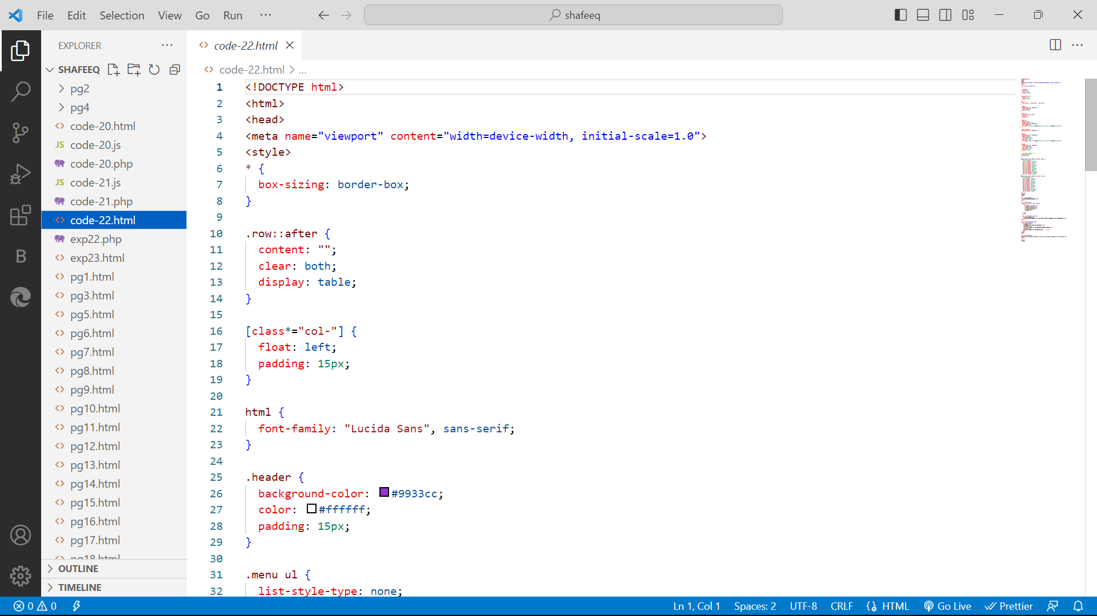

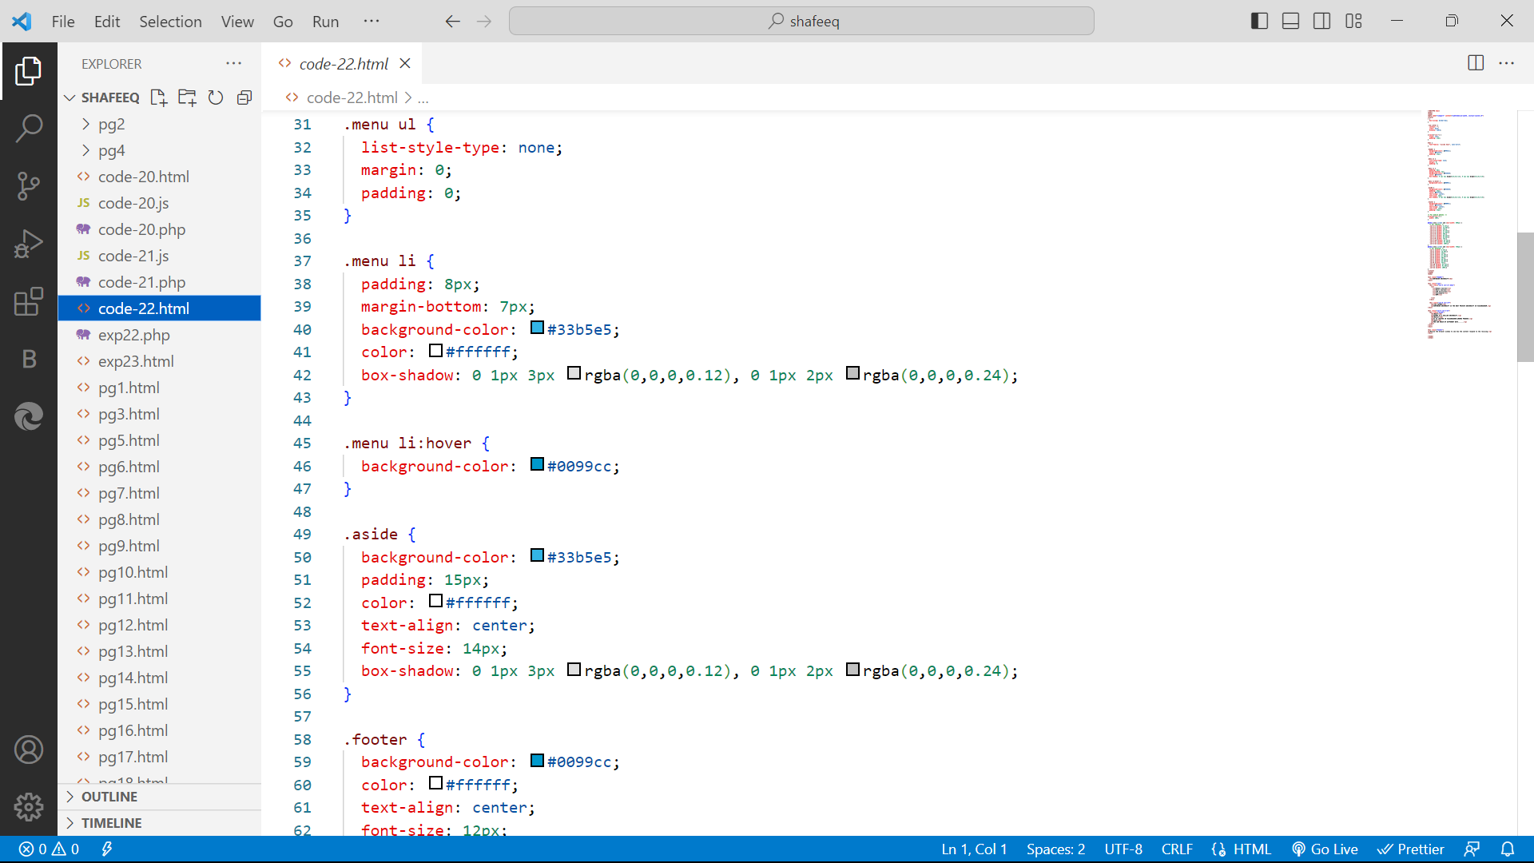

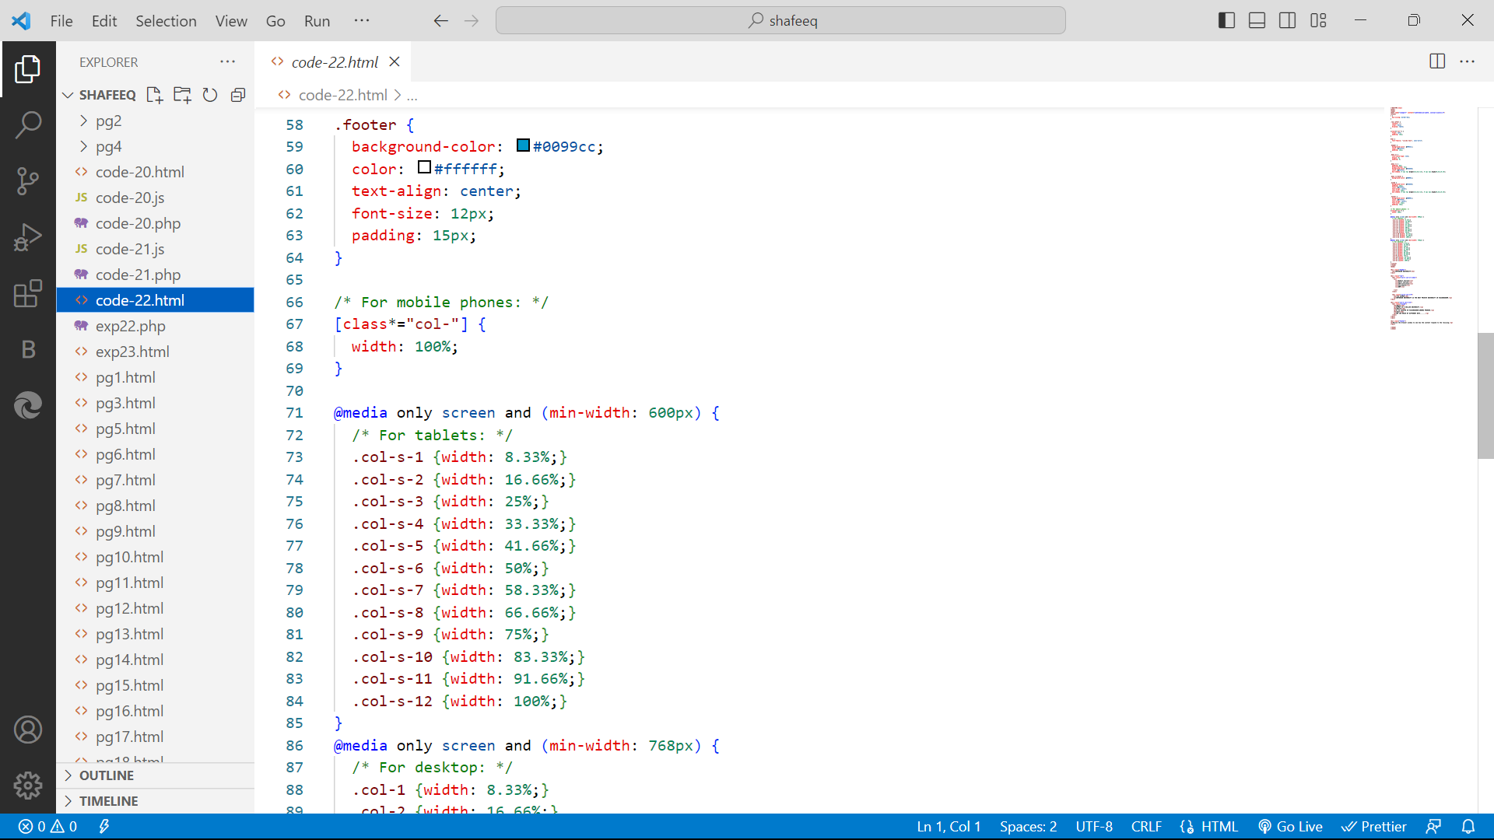

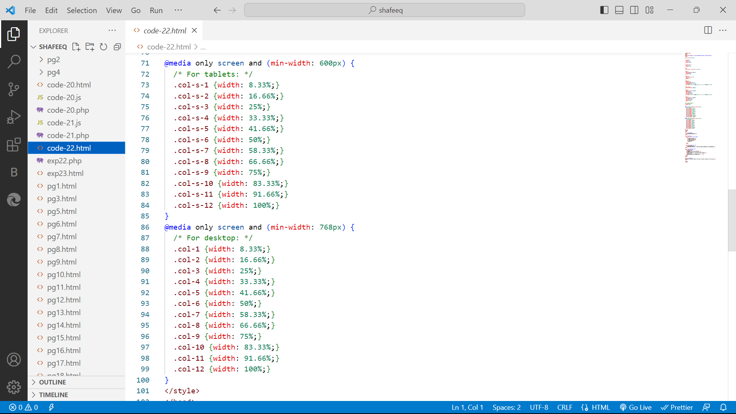

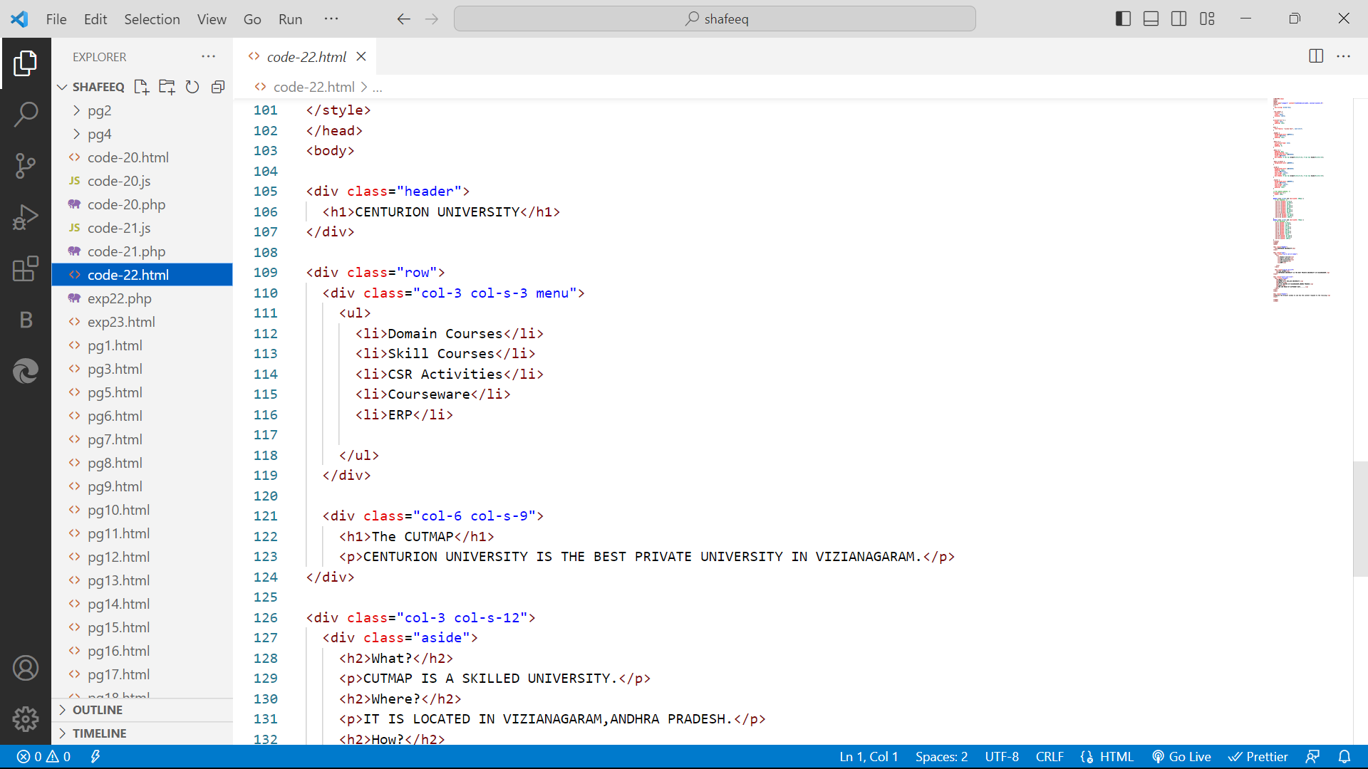

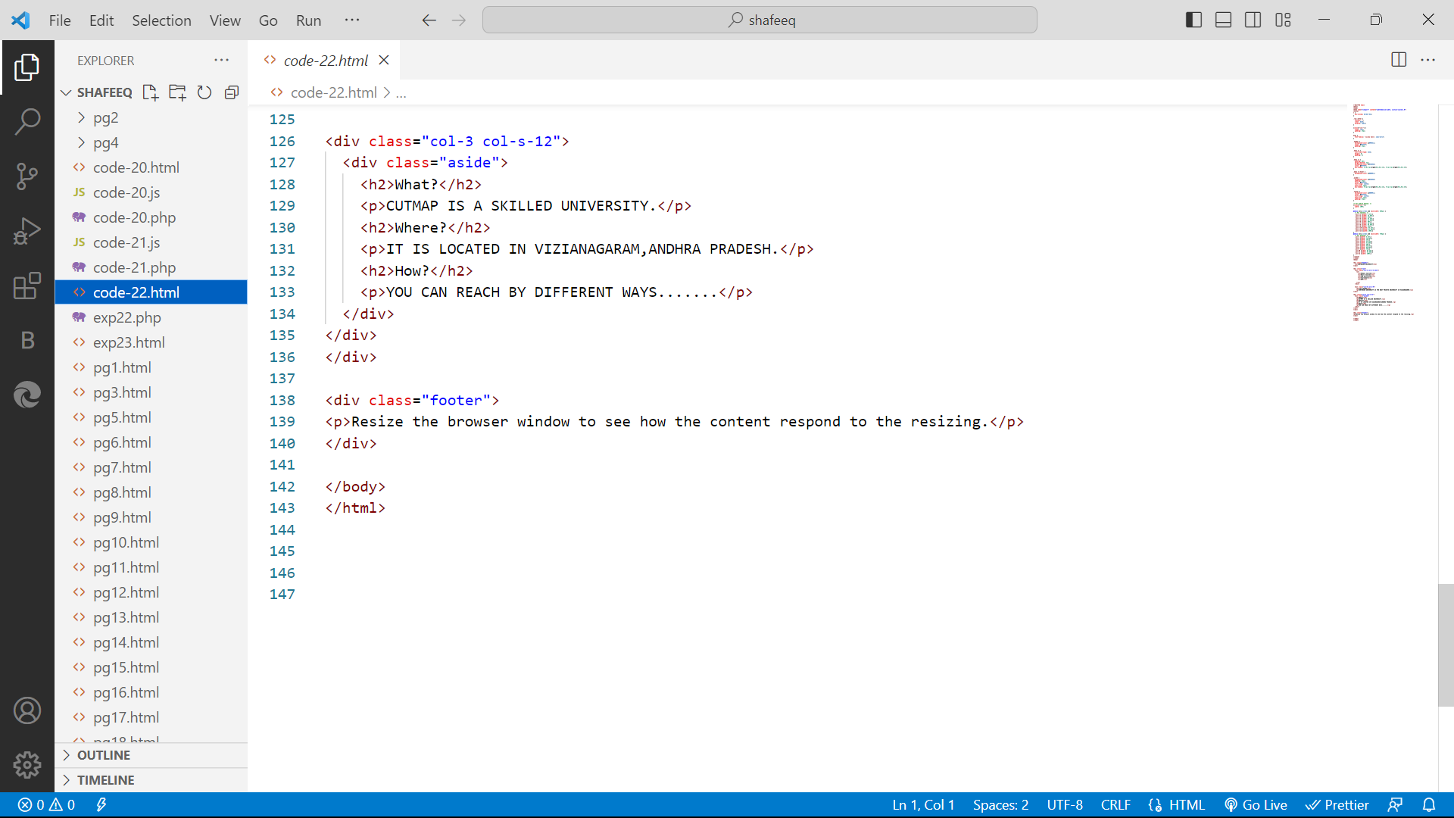

**OUTPUT:**

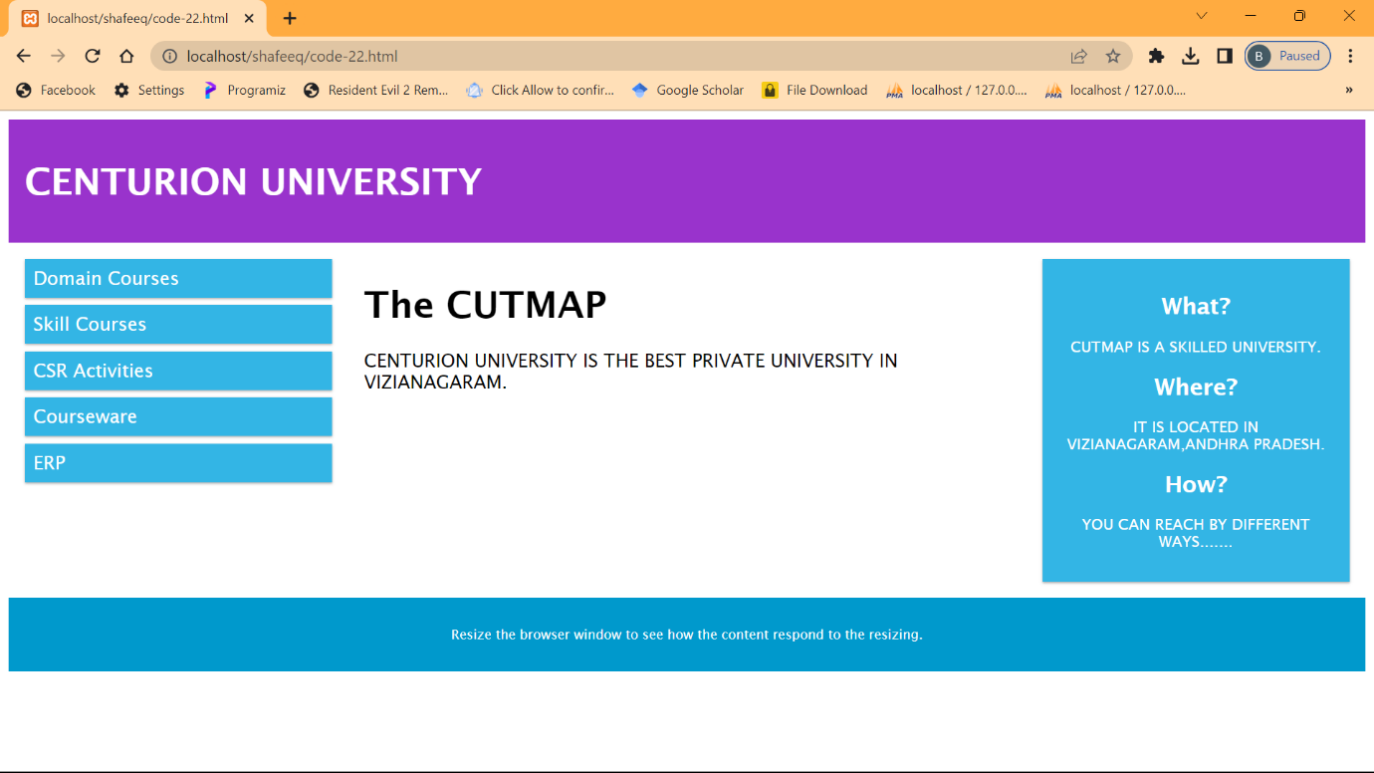

**EXPERIMENT-23**

23.evelop student registration web application using php

**CODE:**

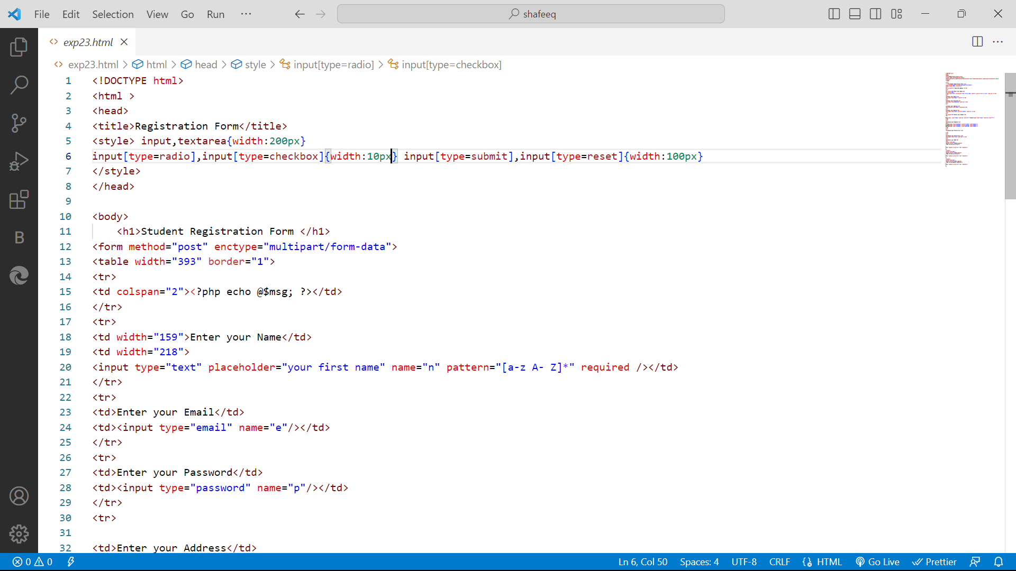

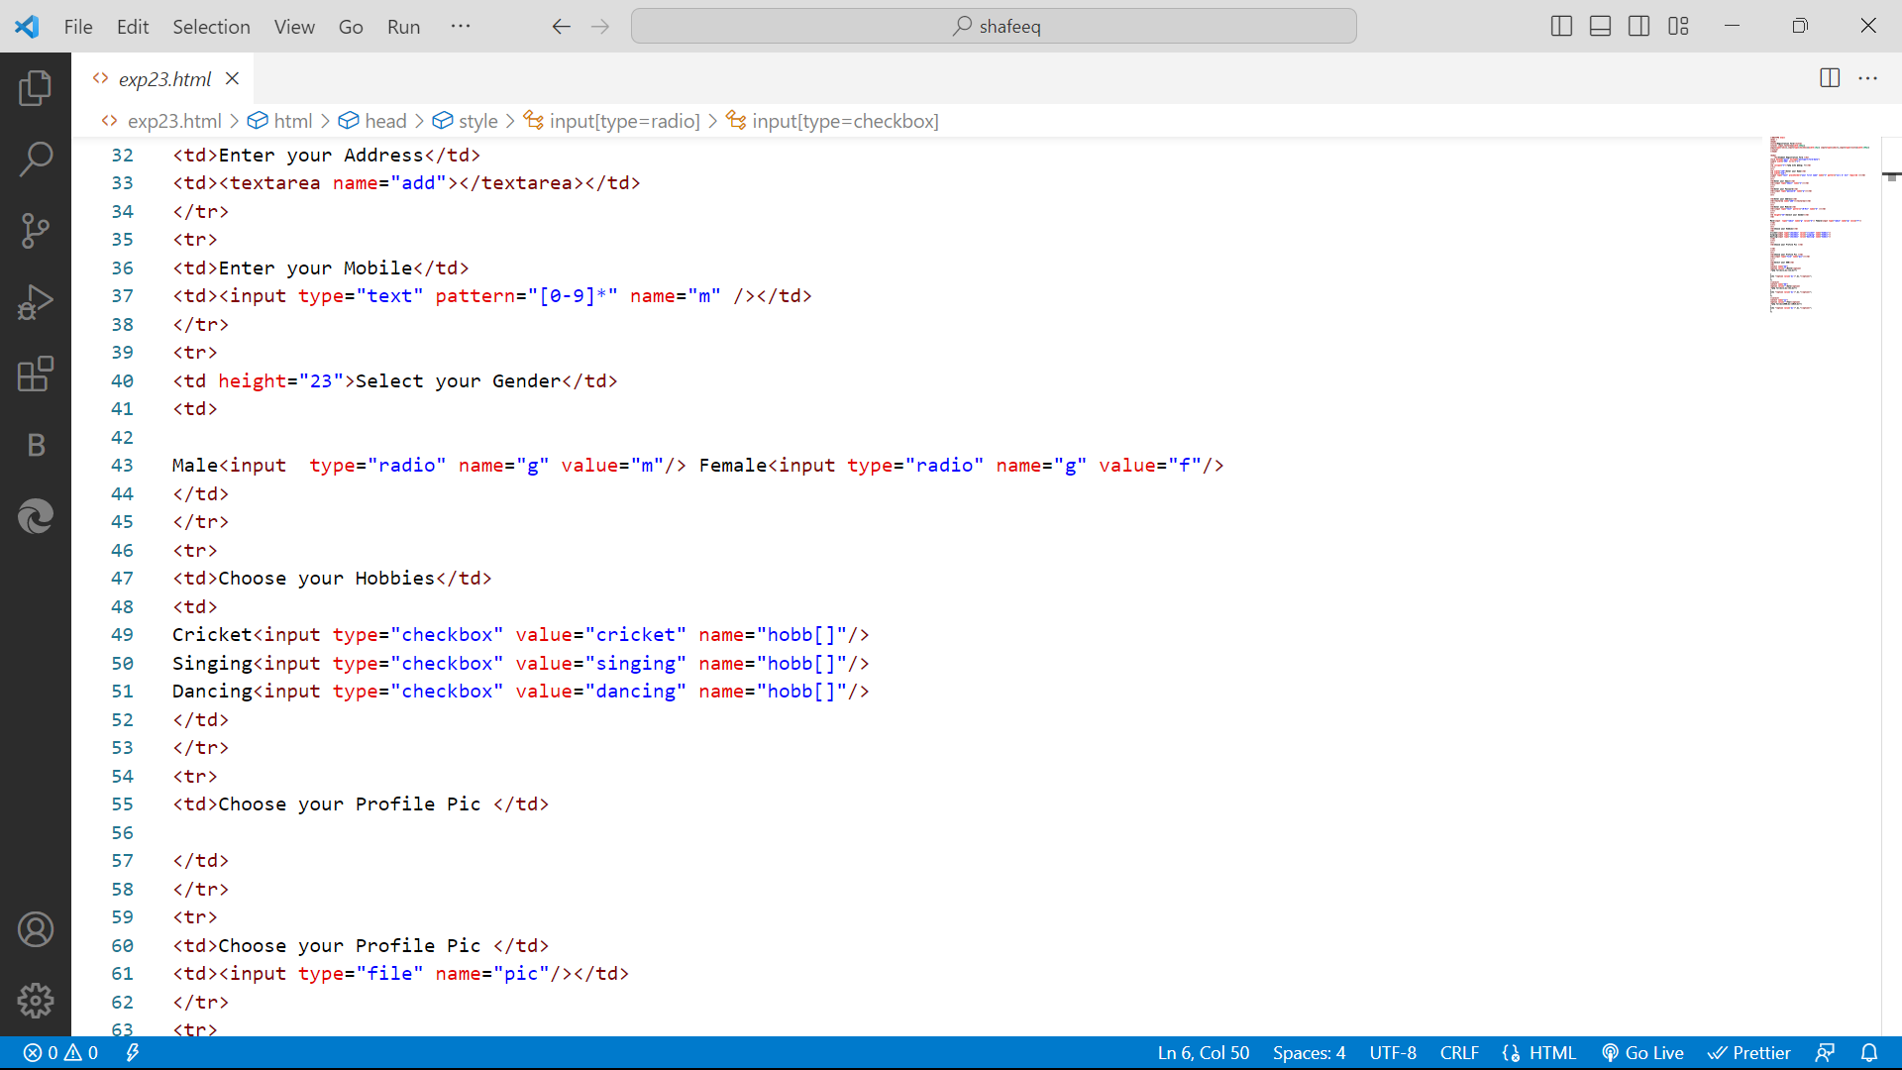

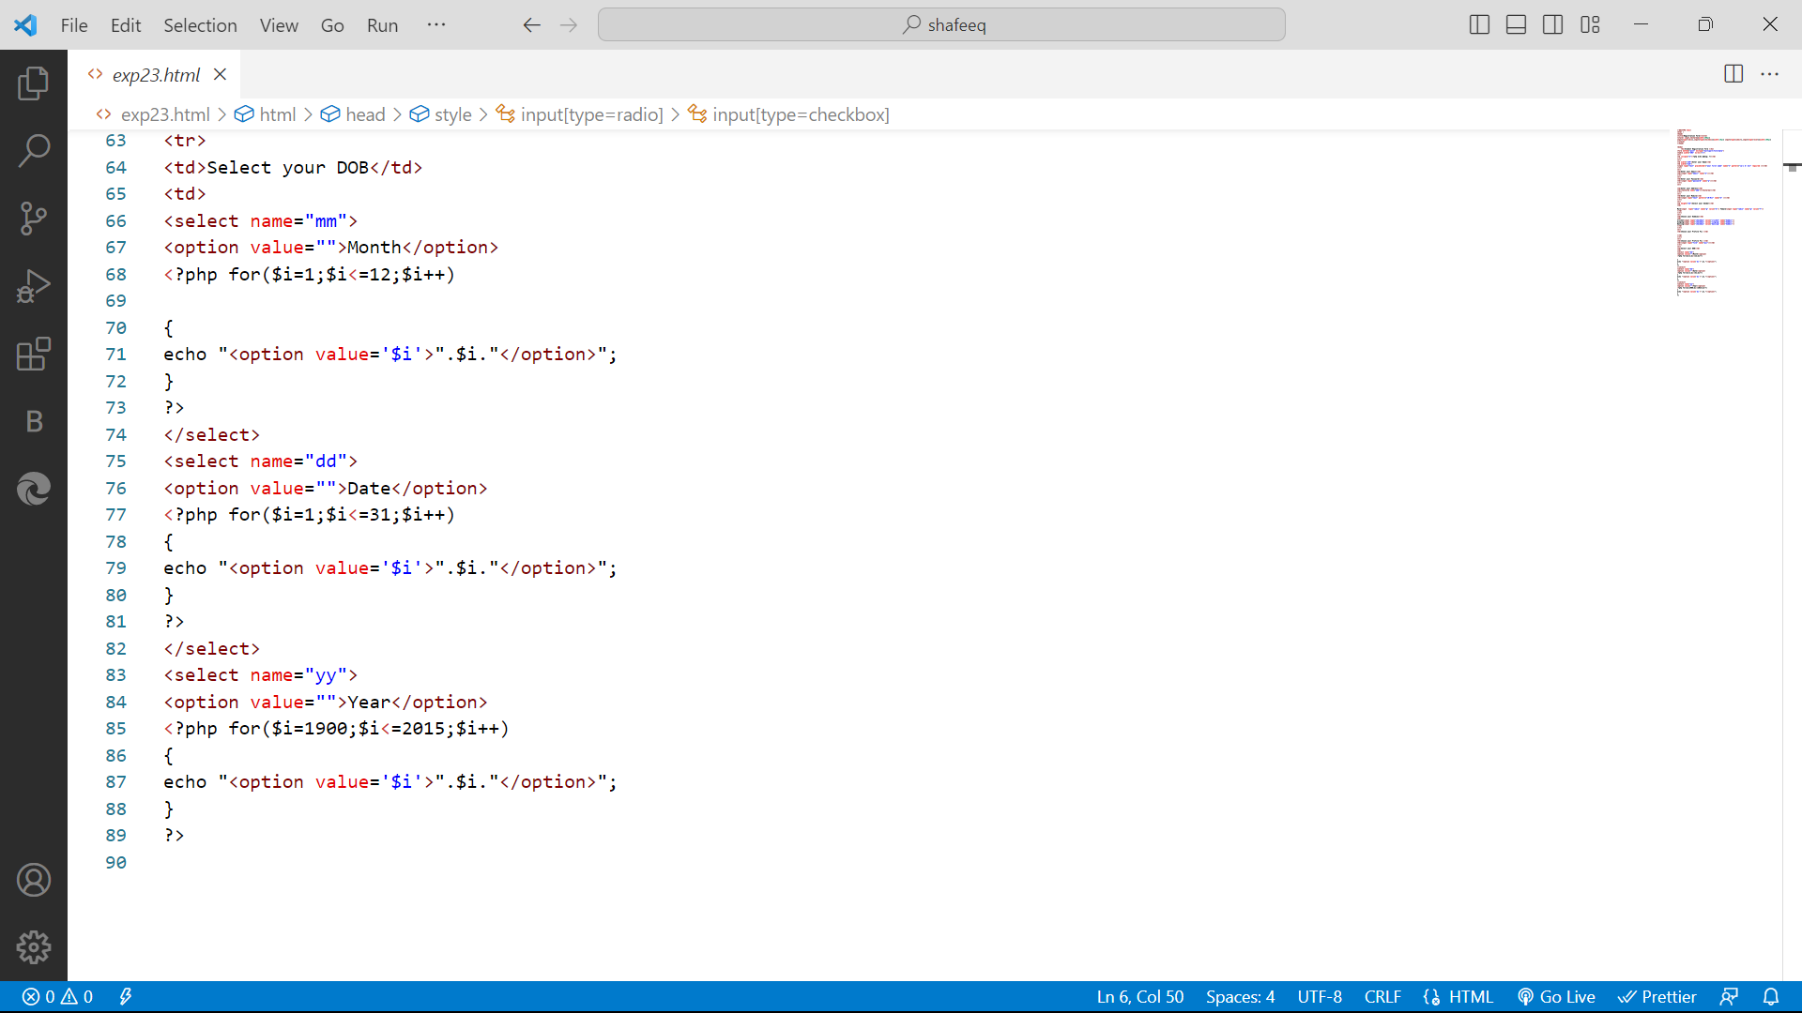

**OUTPUT:**

